Full dataset (bucket-0 dropped): (8569731, 6)
Unique stocks : 112
Unique time_ids: 3830

── TIME_ID SUBSAMPLE ──
Sampled 300 of 3830 time_ids (seed=42)
Sampled time_ids: [256, 650, 745, 748, 785, 1070, 1178, 1227, 1359, 1820, 1904, 2006, 2037, 2185, 2331, 2410, 2444, 2525, 2553, 2593, 2631, 2656, 2659, 2867, 2893, 2917, 3146, 3152, 3406, 3607, 3721, 3884, 3921, 4004, 4158, 4173, 4364, 4493, 4560, 4627, 4723, 4743, 4850, 4905, 5032, 5063, 5305, 5340, 5458, 5470, 5598, 5620, 5743, 5825, 5829, 5916, 6177, 6476, 6626, 6693, 6979, 7041, 7219, 7270, 8081, 8191, 8196, 8256, 8448, 8534, 8583, 8585, 8665, 8721, 8763, 9077, 9153, 9302, 9352, 9367, 9456, 9564, 9700, 9862, 9918, 10017, 10042, 10488, 10604, 10702, 10725, 10776, 10781, 10994, 11090, 11243, 11375, 11508, 11869, 11940, 12030, 12420, 12579, 12581, 12676, 12834, 12957, 12991, 13180, 13235, 13269, 13362, 13382, 13410, 13421, 13432, 13451, 13452, 13598, 13821, 13900, 13941, 13960, 13986, 14001, 14004, 14077, 14125, 14235, 14246, 14247, 14278, 14279, 14311, 14465, 14752, 14769, 14810, 14976, 15061, 15209, 15276, 15280, 15319, 15341, 15400, 15448, 15499, 15516, 15529, 15547, 16086, 16288, 16438, 16570, 16802, 16816, 16910, 17013, 17056, 17058, 17157, 17169, 17172, 17191, 17264, 17398, 17983, 18012, 18180, 18200, 18218, 18400, 18509, 18595, 18629, 18792, 18916, 19065, 19072, 19180, 19226, 19385, 19499, 19554, 19678, 19994, 20063, 20172, 20199, 20317, 20418, 20457, 20469, 20673, 20691, 20732, 20972, 21079, 21083, 21208, 21272, 21428, 21445, 21685, 21734, 22011, 22120, 22217, 22304, 22392, 22519, 22622, 22635, 22750, 22829, 23030, 23185, 23228, 23232, 23337, 23642, 23708, 23819, 23823, 23858, 23903, 24157, 24179, 24388, 24393, 24396, 24473, 24535, 24816, 24817, 25019, 25087, 25312, 25318, 25335, 25369, 25389, 25488, 25501, 25599, 25654, 25854, 26208, 26337, 26447, 26568, 26844, 27020, 27278, 27304, 27313, 27711, 27868, 28070, 28512, 28541, 28634, 28697, 29316, 29507, 29570, 29592, 29853, 30412, 30454, 30527, 30598, 30748, 30790, 30816, 30896, 31055, 31083, 31119, 31138, 31327, 31412, 31482, 31522, 31656, 32126, 32186, 32200, 32249, 32277, 32322, 32376, 32463, 32590, 32653, 32662, 32680, 32746, 32748]
Dataset after time_id filter: (671206, 6)

██████████████████████████████████████████████████████████████████████
PHASE 1 — WLS BASELINE + CROSS-VALIDATION (stock_id = 1)
██████████████████████████████████████████████████████████████████████
stock_id=1 rows: 6,000
Holdout split — Train buckets: 1–16 | Test buckets: 17–20
Train rows: 4,800 Test rows: 1,200
Engineering features …

Running data-driven feature selection on stock_id=1 training data …

[FEATURE SELECTION] Candidate pool : 32 features
[FEATURE SELECTION] Dropped (|r| < 0.05): ['bas_change', 'volume_surge', 'wap_accel']
[FEATURE SELECTION] Dropped (collinear > 0.95): ['activity_vol', 'bas_lag1', 'rel_spread', 'rel_spread_lag1', 'rv_roll_max', 'spread_imbalance', 'spread_vol_interaction']
[FEATURE SELECTION] Final features (22): ['rv_roll_mean', 'bas', 'bas_roll_mean', 'rv_lag1', 'rv_lag2', 'rv_lag3', 'bas_sq', 'log_activity', 'rel_spread_vol', 'log_activity_lag1', 'rv_roll_sd', 'bas_roll_sd', 'inv_spread', 'rv_lag1_sq', 'inv_spread_lag1', 'spread_change_vol', 'rv_roll_cv', 'wap', 'wap_dev', 'wap_return2', 'wap_return', 'bas_pct_change']

── SELECTED FEATURES (22) ──
Feature |r with RV| r Group
─────────────────────────────────────────────────────────────────
rv_roll_mean 0.8748 +0.8748 RV lags/rolling
bas 0.7550 +0.7550 Bid-Ask Spread
bas_roll_mean 0.7537 +0.7537 Bid-Ask Spread
rv_lag1 0.7474 +0.7474 RV lags/rolling
rv_lag2 0.7283 +0.7283 RV lags/rolling
rv_lag3 0.7263 +0.7263 RV lags/rolling
bas_sq 0.6998 +0.6998 Bid-Ask Spread
log_activity 0.6748 -0.6748 Order-flow
rel_spread_vol 0.6632 +0.6632 Interaction/nonlinear
log_activity_lag1 0.6432 -0.6432 Order-flow
rv_roll_sd 0.6365 +0.6365 RV lags/rolling
bas_roll_sd 0.5771 +0.5771 Bid-Ask Spread
inv_spread 0.5353 -0.5353 Order-flow
rv_lag1_sq 0.5302 +0.5302 RV lags/rolling
inv_spread_lag1 0.5030 -0.5030 Order-flow
spread_change_vol 0.2013 -0.2013 Interaction/nonlinear
rv_roll_cv 0.1672 -0.1672 RV lags/rolling
wap 0.1380 +0.1380 Price (WAP)
wap_dev 0.1242 -0.1242 Price (WAP)
wap_return2 0.1047 -0.1047 Price (WAP)
wap_return 0.0853 -0.0853 Price (WAP)
bas_pct_change 0.0500 +0.0500 Bid-Ask Spread

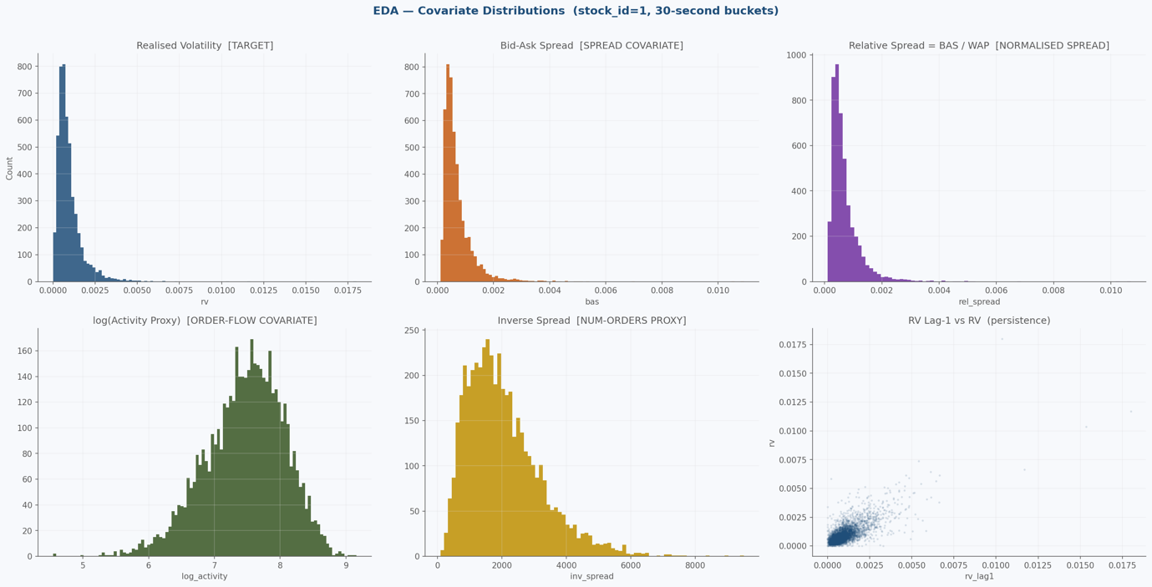

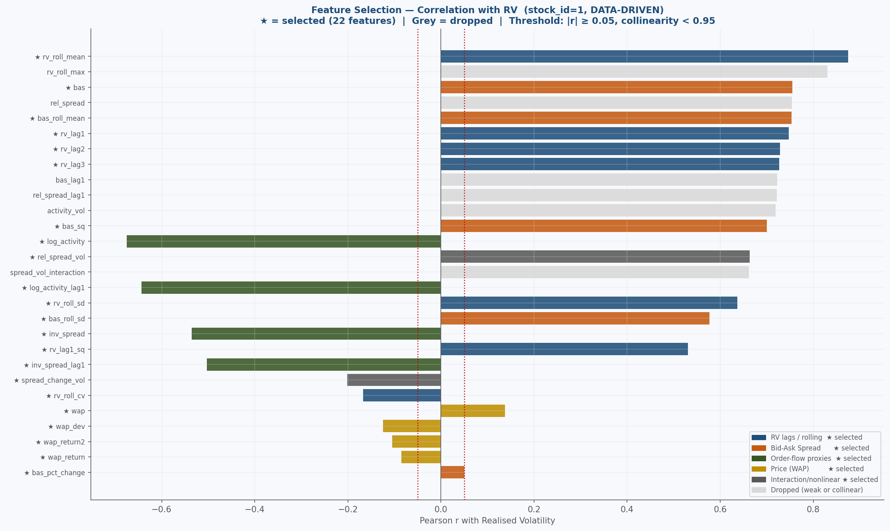

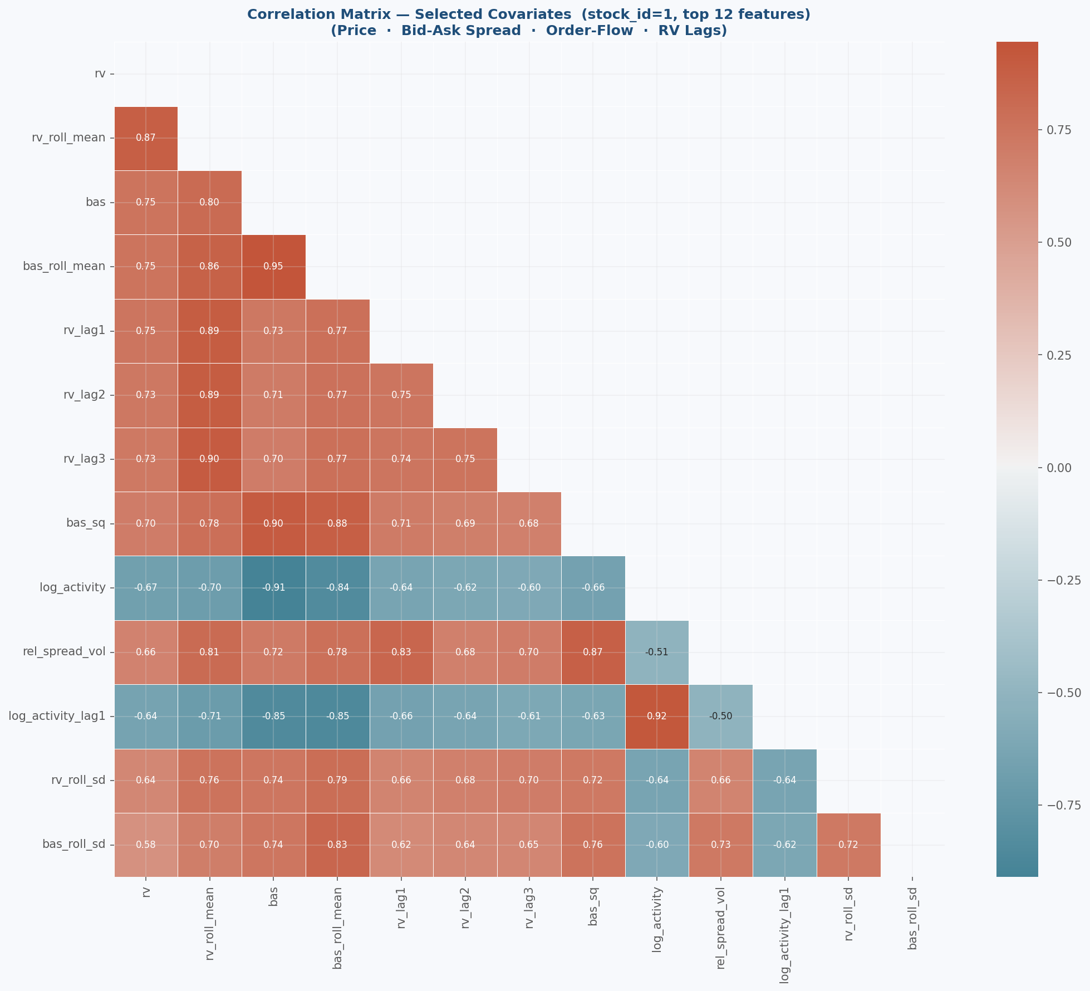

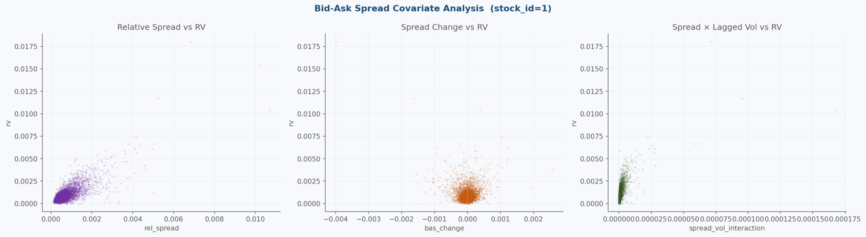

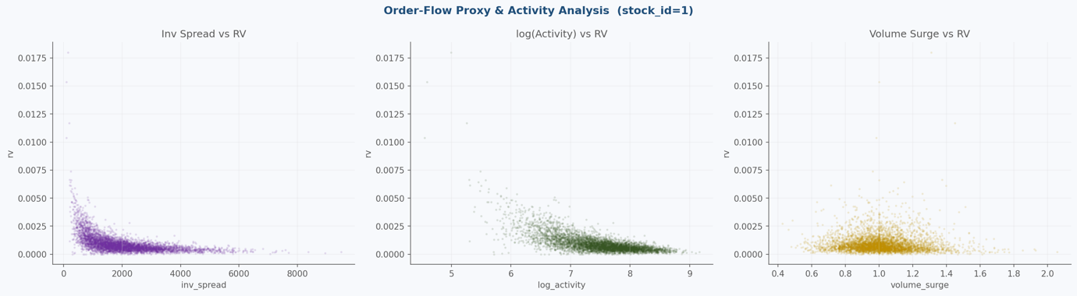

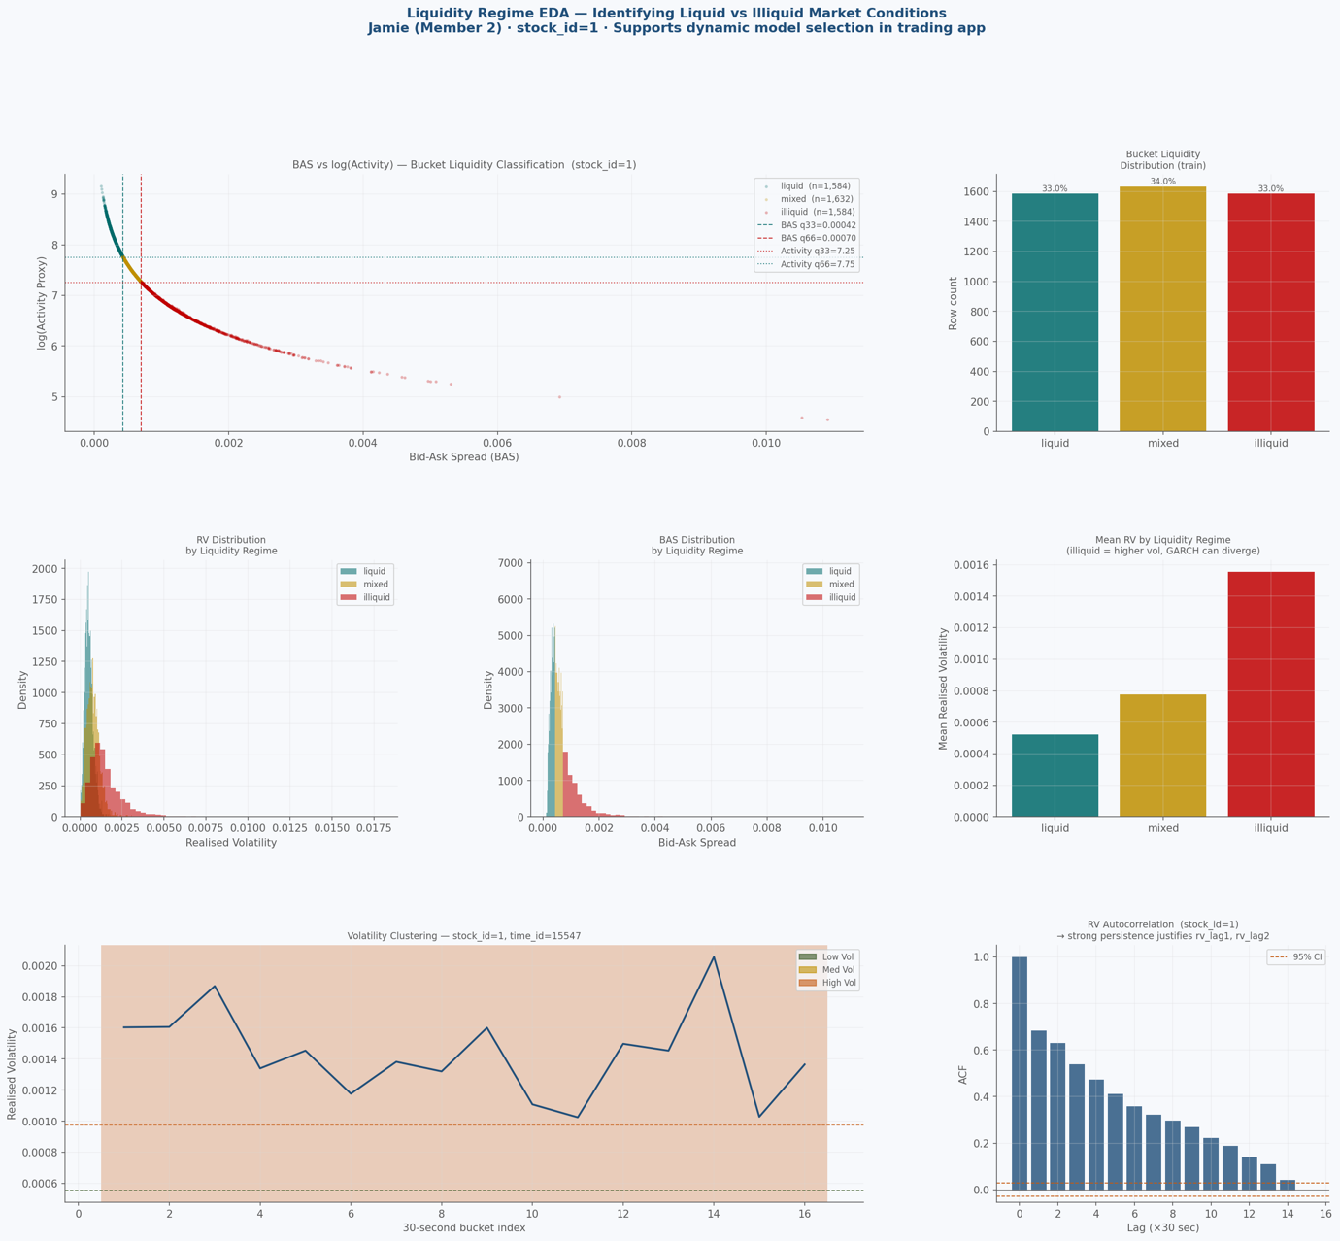

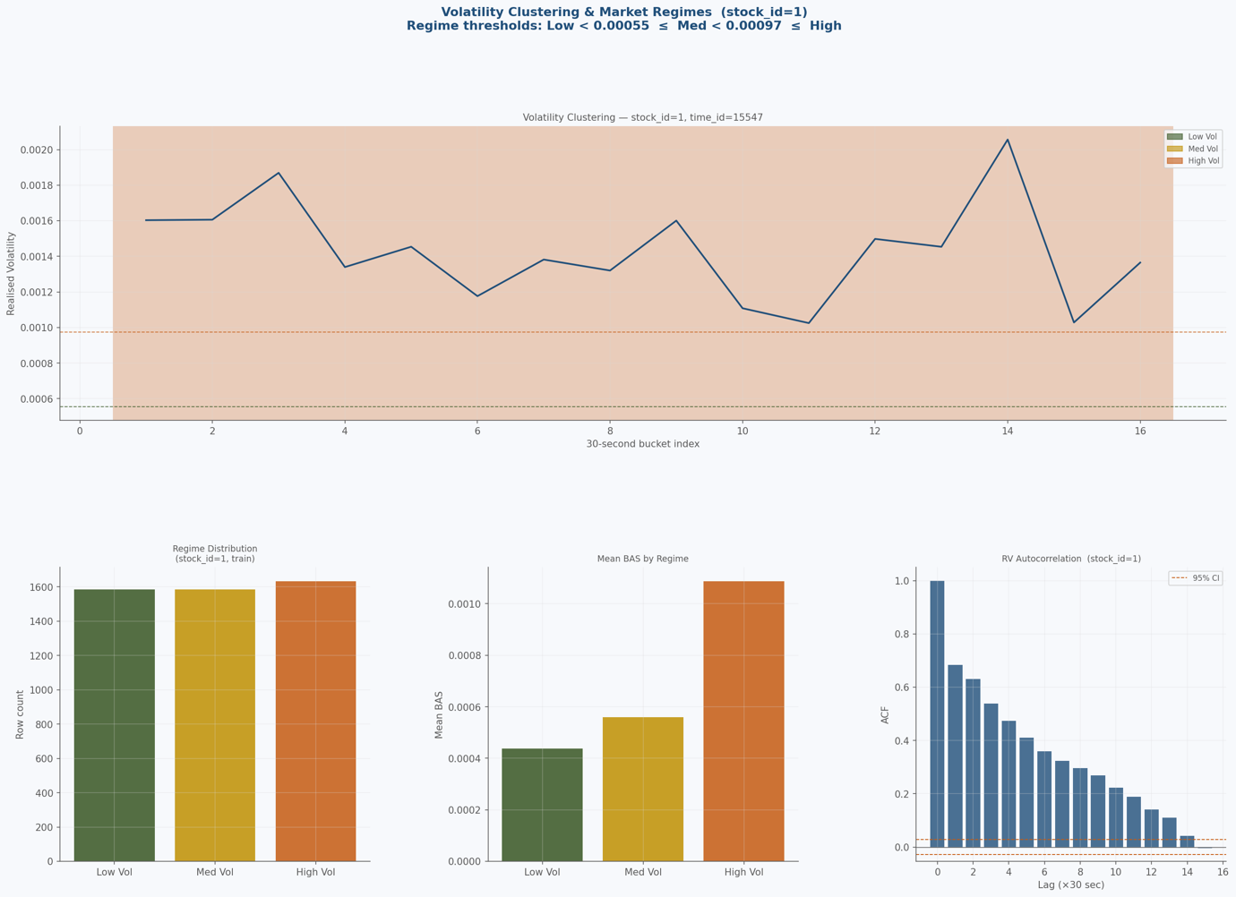

Holdout OLS MSE=0.00000005 QLIKE=-6.288976
Tuning alpha on holdout split …
Holdout best α = 0.61
Holdout WLS MSE=0.00000003 QLIKE=-6.290145

Running 5-fold time-series CV on stock_id=1 …
CV split strategy: TimeSeriesSplit(n_splits=5)
Each fold trains on earlier time_buckets, validates on later ones.

[CV] Fold 1: tr_buckets=4–6 val_buckets=7–8 α=0.05 WLS_QLIKE=-6.188509 OLS_QLIKE=25.047265
[CV] Fold 2: tr_buckets=4–8 val_buckets=9–10 α=0.99 WLS_QLIKE=-6.181983 OLS_QLIKE=-6.181985
[CV] Fold 3: tr_buckets=4–10 val_buckets=11–12 α=0.64 WLS_QLIKE=15.579120 OLS_QLIKE=15.583792
[CV] Fold 4: tr_buckets=4–12 val_buckets=13–14 α=0.98 WLS_QLIKE=-6.192364 OLS_QLIKE=-6.192363
[CV] Fold 5: tr_buckets=4–14 val_buckets=15–16 α=0.99 WLS_QLIKE=-6.206075 OLS_QLIKE=-6.206120

── CV SUMMARY Phase 1 — stock_id=1 ──
Metric Mean Std Min Max
────────────────────────────────────────────────────────────
wls_qlike -1.837962 9.736449 -6.206075 15.579120
wls_mse 0.000000 0.000000 0.000000 0.000000
wls_mae 0.000193 0.000011 0.000182 0.000211
ols_qlike 4.410118 14.900105 -6.206120 25.047265
best_alpha 0.730000 0.408718 0.050000 0.990000

Fold details:
Fold 1: train_buckets=4–6 val_buckets=7–8 n_train=900 n_val=600 α=0.05 QLIKE=-6.188509
Fold 2: train_buckets=4–8 val_buckets=9–10 n_train=1500 n_val=600 α=0.99 QLIKE=-6.181983
Fold 3: train_buckets=4–10 val_buckets=11–12 n_train=2100 n_val=600 α=0.64 QLIKE=15.579120
Fold 4: train_buckets=4–12 val_buckets=13–14 n_train=2700 n_val=600 α=0.98 QLIKE=-6.192364
Fold 5: train_buckets=4–14 val_buckets=15–16 n_train=3300 n_val=600 α=0.99 QLIKE=-6.206075

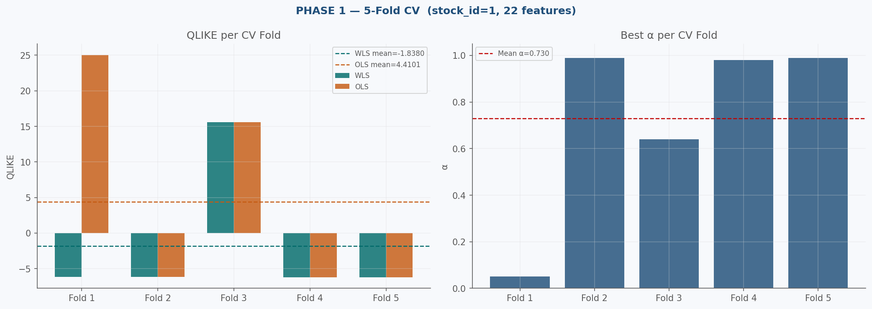

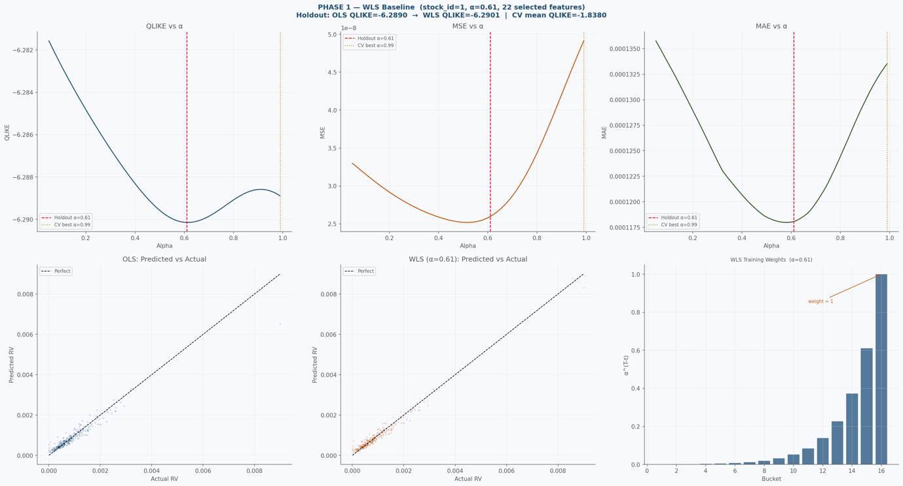

── PHASE 1 SUMMARY ──
Holdout: OLS QLIKE=-6.288976 WLS QLIKE=-6.290145 α=0.61
CV (5-fold): mean QLIKE=-1.837962 std=9.736449 best α=0.99

██████████████████████████████████████████████████████████████████████
PHASE 2 — LIQUIDITY CLASSIFICATION (all stocks)
██████████████████████████████████████████████████████████████████████
Engineering features on full train (537,059 rows) …
Global BAS thresholds : Low < 0.000297 ≤ Med < 0.000616 ≤ High
Global Activity thresh : Low < 7.3658 ≤ Med < 8.0971 ≤ High

Stock-level regime counts:
illiquid : 43 stocks (38.4%)
liquid : 39 stocks (34.8%)
mixed : 30 stocks (26.8%)

── DEMO STOCK SELECTION (random, seed=42) ──
20 RANDOM LIQUID stock_ids : [10, 13, 20, 28, 39, 46, 47, 50, 51, 52, 64, 68, 69, 77, 85, 86, 95, 99, 120, 124]
20 RANDOM MIXED stock_ids : [7, 19, 21, 26, 32, 42, 48, 59, 61, 70, 73, 76, 82, 89, 96, 101, 107, 113, 114, 115]
20 RANDOM ILLIQUID stock_ids : [0, 3, 4, 6, 9, 23, 30, 37, 38, 40, 60, 80, 81, 88, 97, 98, 102, 103, 112, 118]
Total demo stocks: 60

── LIQUID (n=20) ──
stock_id liquid_pct illiquid_pct mixed_pct median_bas median_log_activity recommended_model
10 0.620625 0.092292 0.287083 0.000256 8.266762 EGARCH-X
13 0.791597 0.035953 0.172450 0.000265 8.233605 EGARCH-X
20 0.571250 0.101667 0.327083 0.000268 8.222951 EGARCH-X
28 0.462805 0.115232 0.421963 0.000310 8.075326 EGARCH-X
39 0.737862 0.054803 0.207335 0.000209 8.470804 EGARCH-X
46 0.948333 0.004375 0.047292 0.000208 8.473200 EGARCH-X
47 0.942292 0.004792 0.052917 0.000230 8.374761 EGARCH-X
50 0.812917 0.005417 0.181667 0.000204 8.493820 EGARCH-X
51 0.621250 0.090625 0.288125 0.000262 8.245859 EGARCH-X
52 0.585833 0.071458 0.342708 0.000265 8.232144 EGARCH-X
64 0.784583 0.030625 0.184792 0.000195 8.538586 EGARCH-X
68 0.518125 0.154792 0.327083 0.000290 8.142947 EGARCH-X
69 0.975625 0.002708 0.021667 0.000087 9.332152 EGARCH-X
77 0.586667 0.008958 0.404375 0.000288 8.149085 EGARCH-X
85 0.453750 0.102083 0.444167 0.000310 8.077119 EGARCH-X
86 0.698542 0.045000 0.256458 0.000265 8.234211 EGARCH-X
95 0.492292 0.102917 0.404792 0.000301 8.105475 EGARCH-X
99 0.835000 0.023958 0.141042 0.000197 8.528978 EGARCH-X
120 0.725417 0.050208 0.224375 0.000221 8.413990 EGARCH-X
124 0.939167 0.003958 0.056875 0.000194 8.543684 EGARCH-X

── MIXED (n=20) ──
stock_id liquid_pct illiquid_pct mixed_pct median_bas median_log_activity recommended_model
7 0.090284 0.368641 0.541076 0.000544 7.515027 WLS / HAR-RV
19 0.331527 0.223797 0.444676 0.000381 7.870052 WLS / HAR-RV
21 0.256250 0.030417 0.713333 0.000319 8.045385 WLS / HAR-RV
26 0.396749 0.191290 0.411961 0.000353 7.946891 WLS / HAR-RV
32 0.145833 0.000000 0.854167 0.000391 7.845679 WLS / HAR-RV
42 0.338958 0.177708 0.483333 0.000370 7.900633 WLS / HAR-RV
48 0.196458 0.263958 0.539583 0.000460 7.684079 WLS / HAR-RV
59 0.184792 0.267917 0.547292 0.000451 7.700963 WLS / HAR-RV
61 0.298750 0.092083 0.609167 0.000357 7.936796 WLS / HAR-RV
70 0.369244 0.170869 0.459887 0.000355 7.940705 WLS / HAR-RV
73 0.153750 0.304375 0.541875 0.000483 7.633783 WLS / HAR-RV
76 0.257500 0.226667 0.515833 0.000420 7.774047 WLS / HAR-RV
82 0.181515 0.300438 0.518047 0.000481 7.636460 WLS / HAR-RV
89 0.053992 0.196373 0.749635 0.000399 7.826132 WLS / HAR-RV
96 0.142708 0.256667 0.600625 0.000476 7.647505 WLS / HAR-RV
101 0.244375 0.304375 0.451250 0.000479 7.642078 WLS / HAR-RV
107 0.274906 0.246144 0.478950 0.000401 7.818190 WLS / HAR-RV
113 0.105022 0.243176 0.651802 0.000481 7.637264 WLS / HAR-RV
114 0.117500 0.358125 0.524375 0.000512 7.575803 WLS / HAR-RV
115 0.263761 0.227690 0.508549 0.000414 7.787736 WLS / HAR-RV

── ILLIQUID (n=20) ──
stock_id liquid_pct illiquid_pct mixed_pct median_bas median_log_activity recommended_model
0 0.044648 0.599624 0.355727 0.000723 7.231721 WLS / HAR-RV
3 0.016465 0.758649 0.224885 0.000880 7.034916 WLS / HAR-RV
4 0.040267 0.534530 0.425203 0.000659 7.323537 WLS / HAR-RV
6 0.014804 0.724771 0.260425 0.000820 7.107076 WLS / HAR-RV
9 0.009812 0.791441 0.198747 0.000952 6.956413 WLS / HAR-RV
23 0.096270 0.428631 0.475099 0.000570 7.467729 WLS / HAR-RV
30 0.091839 0.514715 0.393446 0.000644 7.345806 WLS / HAR-RV
37 0.000631 0.945309 0.054060 0.001340 6.614372 WLS / HAR-RV
38 0.036906 0.526897 0.436197 0.000654 7.330415 WLS / HAR-RV
40 0.006884 0.809345 0.183771 0.000937 6.972510 WLS / HAR-RV
60 0.098494 0.477206 0.424299 0.000608 7.403660 WLS / HAR-RV
80 0.020938 0.624372 0.354690 0.000764 7.176270 WLS / HAR-RV
81 0.082517 0.471557 0.445926 0.000609 7.399988 WLS / HAR-RV
88 0.017187 0.774890 0.207923 0.000956 6.951919 WLS / HAR-RV
97 0.001876 0.849489 0.148635 0.001044 6.864600 WLS / HAR-RV
98 0.024242 0.688401 0.287356 0.000800 7.130642 WLS / HAR-RV
102 0.074823 0.491663 0.433514 0.000622 7.380114 WLS / HAR-RV
103 0.009397 0.743997 0.246607 0.000884 7.031105 WLS / HAR-RV
112 0.008996 0.853556 0.137448 0.001086 6.825262 WLS / HAR-RV
118 0.029596 0.562734 0.407670 0.000675 7.299888 WLS / HAR-RV

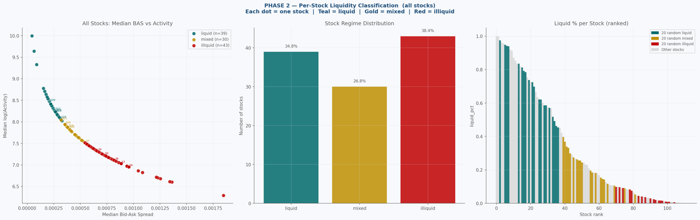

██████████████████████████████████████████████████████████████████████
PHASE 3 — WLS + CV ON 60 DEMO STOCKS
20 random liquid + 20 random mixed + 20 random illiquid
Using 22 features selected in Phase 1
██████████████████████████████████████████████████████████████████████
Engineering features …
Tuning alpha on holdout split …
Holdout best α = 0.99
Holdout: OLS QLIKE=-6.507159 WLS QLIKE=-6.507046

Running 5-fold time-series CV on 60 demo stocks (pooled) …
[CV] Fold 1: tr_buckets=4–6 val_buckets=7–8 α=0.14 WLS_QLIKE=-1.282753 OLS_QLIKE=12.408802
[CV] Fold 2: tr_buckets=4–8 val_buckets=9–10 α=0.06 WLS_QLIKE=1.812762 OLS_QLIKE=4.363224
[CV] Fold 3: tr_buckets=4–10 val_buckets=11–12 α=0.42 WLS_QLIKE=0.518885 OLS_QLIKE=2.855724
[CV] Fold 4: tr_buckets=4–12 val_buckets=13–14 α=0.80 WLS_QLIKE=-0.132475 OLS_QLIKE=1.219941
[CV] Fold 5: tr_buckets=4–14 val_buckets=15–16 α=0.05 WLS_QLIKE=0.708474 OLS_QLIKE=2.096561

── CV SUMMARY Phase 3 — 60 demo stocks (pooled) ──
Metric Mean Std Min Max
────────────────────────────────────────────────────────────
wls_qlike 0.324978 1.139323 -1.282753 1.812762
wls_mse 0.000000 0.000000 0.000000 0.000000
wls_mae 0.000183 0.000005 0.000179 0.000190
ols_qlike 4.588851 4.521265 1.219941 12.408802
best_alpha 0.294000 0.320125 0.050000 0.800000

Fold details:
Fold 1: train_buckets=4–6 val_buckets=7–8 n_train=53918 n_val=35970 α=0.14 QLIKE=-1.282753
Fold 2: train_buckets=4–8 val_buckets=9–10 n_train=89888 n_val=35958 α=0.06 QLIKE=1.812762
Fold 3: train_buckets=4–10 val_buckets=11–12 n_train=125846 n_val=35965 α=0.42 QLIKE=0.518885
Fold 4: train_buckets=4–12 val_buckets=13–14 n_train=161811 n_val=35964 α=0.80 QLIKE=-0.132475
Fold 5: train_buckets=4–14 val_buckets=15–16 n_train=197775 n_val=35968 α=0.05 QLIKE=0.708474

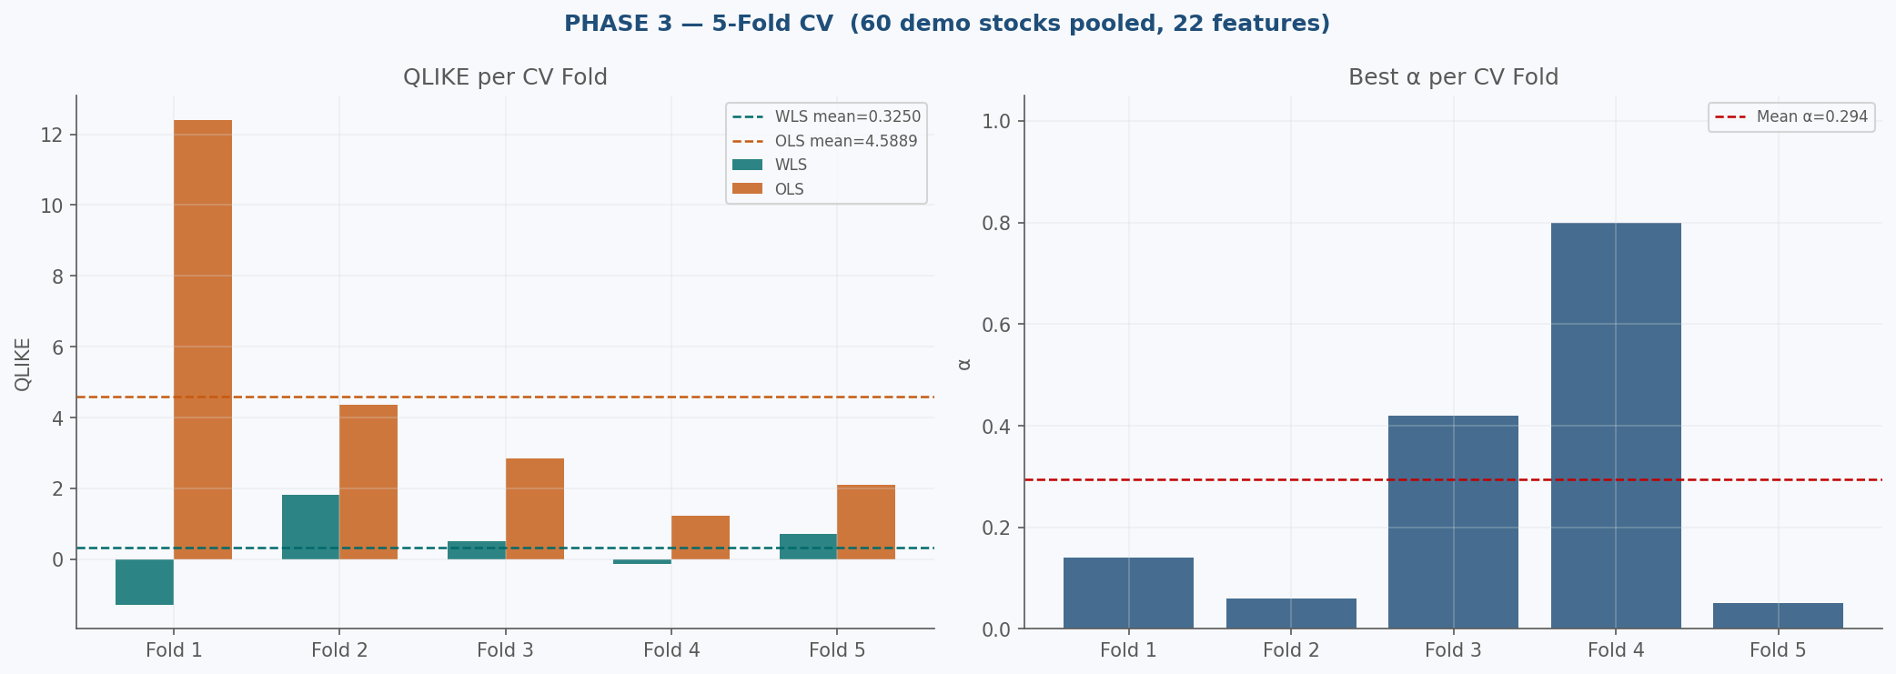

Running per-stock 5-fold CV …
[CV] Fold 1: tr_buckets=4–6 val_buckets=7–8 α=0.16 WLS_QLIKE=-6.390704 OLS_QLIKE=-6.380993
[CV] Fold 1: tr_buckets=4–6 val_buckets=7–8 α=0.99 WLS_QLIKE=-6.761442 OLS_QLIKE=-6.761452
[CV] Fold 1: tr_buckets=4–6 val_buckets=7–8 α=0.99 WLS_QLIKE=-6.554807 OLS_QLIKE=-6.554809
[CV] Fold 1: tr_buckets=4–6 val_buckets=7–8 α=0.85 WLS_QLIKE=-6.676758 OLS_QLIKE=-6.676508
[CV] Fold 1: tr_buckets=4–6 val_buckets=7–8 α=0.22 WLS_QLIKE=-6.922767 OLS_QLIKE=2.989687
[CV] Fold 1: tr_buckets=4–6 val_buckets=7–8 α=0.34 WLS_QLIKE=-6.605801 OLS_QLIKE=-6.603024
[CV] Fold 1: tr_buckets=4–6 val_buckets=7–8 α=0.51 WLS_QLIKE=-7.028861 OLS_QLIKE=-7.027065
[CV] Fold 1: tr_buckets=4–6 val_buckets=7–8 α=0.28 WLS_QLIKE=-6.377897 OLS_QLIKE=-6.375900
[CV] Fold 2: tr_buckets=4–8 val_buckets=9–10 α=0.99 WLS_QLIKE=-6.406524 OLS_QLIKE=-6.406555
[CV] Fold 2: tr_buckets=4–8 val_buckets=9–10 α=0.99 WLS_QLIKE=-6.813791 OLS_QLIKE=-6.813836
[CV] Fold 2: tr_buckets=4–8 val_buckets=9–10 α=0.87 WLS_QLIKE=-6.859260 OLS_QLIKE=-6.858695
[CV] Fold 2: tr_buckets=4–8 val_buckets=9–10 α=0.99 WLS_QLIKE=-6.681347 OLS_QLIKE=-6.681396
[CV] Fold 2: tr_buckets=4–8 val_buckets=9–10 α=0.99 WLS_QLIKE=-7.034909 OLS_QLIKE=-7.035129
[CV] Fold 2: tr_buckets=4–8 val_buckets=9–10 α=0.99 WLS_QLIKE=-6.628999 OLS_QLIKE=-6.629036
[CV] Fold 2: tr_buckets=4–8 val_buckets=9–10 α=0.99 WLS_QLIKE=-6.535647 OLS_QLIKE=-6.535667
[CV] Fold 2: tr_buckets=4–8 val_buckets=9–10 α=0.96 WLS_QLIKE=-6.391390 OLS_QLIKE=-6.391385
[CV] Fold 3: tr_buckets=4–10 val_buckets=11–12 α=0.91 WLS_QLIKE=-6.886912 OLS_QLIKE=-6.886700
[CV] Fold 3: tr_buckets=4–10 val_buckets=11–12 α=0.99 WLS_QLIKE=-6.708555 OLS_QLIKE=-6.708587
[CV] Fold 3: tr_buckets=4–10 val_buckets=11–12 α=0.99 WLS_QLIKE=-6.809025 OLS_QLIKE=-6.809184
[CV] Fold 3: tr_buckets=4–10 val_buckets=11–12 α=0.66 WLS_QLIKE=-6.414239 OLS_QLIKE=-6.413841
[CV] Fold 3: tr_buckets=4–10 val_buckets=11–12 α=0.59 WLS_QLIKE=-6.648057 OLS_QLIKE=-6.648037
[CV] Fold 3: tr_buckets=4–10 val_buckets=11–12 α=0.59 WLS_QLIKE=-7.033890 OLS_QLIKE=-7.031793
[CV] Fold 3: tr_buckets=4–10 val_buckets=11–12 α=0.99 WLS_QLIKE=-6.562647 OLS_QLIKE=-6.562713
[CV] Fold 3: tr_buckets=4–10 val_buckets=11–12 α=0.99 WLS_QLIKE=-6.421995 OLS_QLIKE=-6.421996
[CV] Fold 4: tr_buckets=4–12 val_buckets=13–14 α=0.77 WLS_QLIKE=-6.814709 OLS_QLIKE=-6.814551
[CV] Fold 4: tr_buckets=4–12 val_buckets=13–14 α=0.21 WLS_QLIKE=-6.922682 OLS_QLIKE=-6.921723
[CV] Fold 4: tr_buckets=4–12 val_buckets=13–14 α=0.99 WLS_QLIKE=-6.408010 OLS_QLIKE=-6.408018
[CV] Fold 4: tr_buckets=4–12 val_buckets=13–14 α=0.99 WLS_QLIKE=-6.680977 OLS_QLIKE=-6.681405
[CV] Fold 4: tr_buckets=4–12 val_buckets=13–14 α=0.77 WLS_QLIKE=-6.709531 OLS_QLIKE=-6.706890
[CV] Fold 4: tr_buckets=4–12 val_buckets=13–14 α=0.86 WLS_QLIKE=-7.058289 OLS_QLIKE=-7.057832
[CV] Fold 4: tr_buckets=4–12 val_buckets=13–14 α=0.99 WLS_QLIKE=-6.587214 OLS_QLIKE=-6.587229
[CV] Fold 4: tr_buckets=4–12 val_buckets=13–14 α=0.99 WLS_QLIKE=-6.429905 OLS_QLIKE=-6.429909
[CV] Fold 5: tr_buckets=4–14 val_buckets=15–16 α=0.77 WLS_QLIKE=-6.411246 OLS_QLIKE=-6.410816
[CV] Fold 5: tr_buckets=4–14 val_buckets=15–16 α=0.63 WLS_QLIKE=-6.910609 OLS_QLIKE=-6.910079
[CV] Fold 5: tr_buckets=4–14 val_buckets=15–16 α=0.80 WLS_QLIKE=-6.820310 OLS_QLIKE=-6.818890
[CV] Fold 5: tr_buckets=4–14 val_buckets=15–16 α=0.54 WLS_QLIKE=-6.701725 OLS_QLIKE=-4.370223
[CV] Fold 5: tr_buckets=4–14 val_buckets=15–16 α=0.99 WLS_QLIKE=-7.062426 OLS_QLIKE=-7.062509
[CV] Fold 5: tr_buckets=4–14 val_buckets=15–16 α=0.99 WLS_QLIKE=-6.676710 OLS_QLIKE=-6.676734
[CV] Fold 5: tr_buckets=4–14 val_buckets=15–16 α=0.80 WLS_QLIKE=-6.595272 OLS_QLIKE=-6.594082
[CV] Fold 5: tr_buckets=4–14 val_buckets=15–16 α=0.86 WLS_QLIKE=-6.410567 OLS_QLIKE=-6.410424
[CV] Fold 1: tr_buckets=4–6 val_buckets=7–8 α=0.12 WLS_QLIKE=-6.483073 OLS_QLIKE=-6.470003
[CV] Fold 1: tr_buckets=4–6 val_buckets=7–8 α=0.61 WLS_QLIKE=-6.700556 OLS_QLIKE=-6.696307
[CV] Fold 1: tr_buckets=4–6 val_buckets=7–8 α=0.19 WLS_QLIKE=-6.780319 OLS_QLIKE=-3.821024
[CV] Fold 1: tr_buckets=4–6 val_buckets=7–8 α=0.83 WLS_QLIKE=-6.613250 OLS_QLIKE=-6.612733
[CV] Fold 1: tr_buckets=4–6 val_buckets=7–8 α=0.88 WLS_QLIKE=-6.701580 OLS_QLIKE=-6.701554
[CV] Fold 1: tr_buckets=4–6 val_buckets=7–8 α=0.08 WLS_QLIKE=15.162252 OLS_QLIKE=23.599885
[CV] Fold 2: tr_buckets=4–8 val_buckets=9–10 α=0.96 WLS_QLIKE=-6.504999 OLS_QLIKE=-6.504985
[CV] Fold 2: tr_buckets=4–8 val_buckets=9–10 α=0.45 WLS_QLIKE=-6.699946 OLS_QLIKE=-6.698035
[CV] Fold 2: tr_buckets=4–8 val_buckets=9–10 α=0.18 WLS_QLIKE=-6.782803 OLS_QLIKE=-6.782396
[CV] Fold 1: tr_buckets=4–6 val_buckets=7–8 α=0.51 WLS_QLIKE=-6.635936 OLS_QLIKE=-3.140469
[CV] Fold 2: tr_buckets=4–8 val_buckets=9–10 α=0.10 WLS_QLIKE=-6.580011 OLS_QLIKE=-4.363491
[CV] Fold 2: tr_buckets=4–8 val_buckets=9–10 α=0.65 WLS_QLIKE=-6.744657 OLS_QLIKE=-6.744588
[CV] Fold 2: tr_buckets=4–8 val_buckets=9–10 α=0.13 WLS_QLIKE=-1.417497 OLS_QLIKE=18.340531
[CV] Fold 1: tr_buckets=4–6 val_buckets=7–8 α=0.05 WLS_QLIKE=-6.514755 OLS_QLIKE=-3.343623
[CV] Fold 3: tr_buckets=4–10 val_buckets=11–12 α=0.64 WLS_QLIKE=-6.521473 OLS_QLIKE=-6.520651
[CV] Fold 3: tr_buckets=4–10 val_buckets=11–12 α=0.99 WLS_QLIKE=-6.733518 OLS_QLIKE=-6.733529
[CV] Fold 3: tr_buckets=4–10 val_buckets=11–12 α=0.47 WLS_QLIKE=-6.782047 OLS_QLIKE=-6.781136
[CV] Fold 2: tr_buckets=4–8 val_buckets=9–10 α=0.98 WLS_QLIKE=-6.660291 OLS_QLIKE=-6.660268
[CV] Fold 3: tr_buckets=4–10 val_buckets=11–12 α=0.99 WLS_QLIKE=-6.593886 OLS_QLIKE=-6.593904
[CV] Fold 2: tr_buckets=4–8 val_buckets=9–10 α=0.97 WLS_QLIKE=-6.558170 OLS_QLIKE=-6.558163
[CV] Fold 3: tr_buckets=4–10 val_buckets=11–12 α=0.99 WLS_QLIKE=-6.470830 OLS_QLIKE=-6.470860
[CV] Fold 3: tr_buckets=4–10 val_buckets=11–12 α=0.34 WLS_QLIKE=-6.744630 OLS_QLIKE=-6.744166
[CV] Fold 4: tr_buckets=4–12 val_buckets=13–14 α=0.78 WLS_QLIKE=-6.544070 OLS_QLIKE=-6.543818
[CV] Fold 4: tr_buckets=4–12 val_buckets=13–14 α=0.68 WLS_QLIKE=-6.744113 OLS_QLIKE=-6.743535
[CV] Fold 4: tr_buckets=4–12 val_buckets=13–14 α=0.99 WLS_QLIKE=-6.795237 OLS_QLIKE=-6.795259
[CV] Fold 3: tr_buckets=4–10 val_buckets=11–12 α=0.98 WLS_QLIKE=-6.667210 OLS_QLIKE=-6.667202
[CV] Fold 4: tr_buckets=4–12 val_buckets=13–14 α=0.99 WLS_QLIKE=-6.615806 OLS_QLIKE=-6.615824
[CV] Fold 3: tr_buckets=4–10 val_buckets=11–12 α=0.44 WLS_QLIKE=-6.595833 OLS_QLIKE=-6.595316
[CV] Fold 4: tr_buckets=4–12 val_buckets=13–14 α=0.99 WLS_QLIKE=-6.746222 OLS_QLIKE=-6.746225
[CV] Fold 4: tr_buckets=4–12 val_buckets=13–14 α=0.96 WLS_QLIKE=-6.430825 OLS_QLIKE=-6.430614
[CV] Fold 5: tr_buckets=4–14 val_buckets=15–16 α=0.99 WLS_QLIKE=-6.563202 OLS_QLIKE=-6.563377
[CV] Fold 5: tr_buckets=4–14 val_buckets=15–16 α=0.82 WLS_QLIKE=-6.731523 OLS_QLIKE=-6.730746
[CV] Fold 5: tr_buckets=4–14 val_buckets=15–16 α=0.99 WLS_QLIKE=-6.792846 OLS_QLIKE=-6.792941
[CV] Fold 4: tr_buckets=4–12 val_buckets=13–14 α=0.99 WLS_QLIKE=4.625880 OLS_QLIKE=4.611475
[CV] Fold 4: tr_buckets=4–12 val_buckets=13–14 α=0.99 WLS_QLIKE=-6.682616 OLS_QLIKE=-6.682640
[CV] Fold 5: tr_buckets=4–14 val_buckets=15–16 α=0.99 WLS_QLIKE=-6.596833 OLS_QLIKE=-6.596833
[CV] Fold 5: tr_buckets=4–14 val_buckets=15–16 α=0.05 WLS_QLIKE=-6.737268 OLS_QLIKE=-6.737291
[CV] Fold 5: tr_buckets=4–14 val_buckets=15–16 α=0.39 WLS_QLIKE=-6.430092 OLS_QLIKE=-6.087954
[CV] Fold 5: tr_buckets=4–14 val_buckets=15–16 α=0.97 WLS_QLIKE=-6.609855 OLS_QLIKE=-6.609826
[CV] Fold 5: tr_buckets=4–14 val_buckets=15–16 α=0.36 WLS_QLIKE=-6.706534 OLS_QLIKE=-6.704280
[CV] Fold 1: tr_buckets=4–6 val_buckets=7–8 α=0.67 WLS_QLIKE=-6.489021 OLS_QLIKE=-6.487957
[CV] Fold 1: tr_buckets=4–6 val_buckets=7–8 α=0.99 WLS_QLIKE=82.652636 OLS_QLIKE=82.650070
[CV] Fold 1: tr_buckets=4–6 val_buckets=7–8 α=0.50 WLS_QLIKE=-0.085206 OLS_QLIKE=13.737218
[CV] Fold 1: tr_buckets=4–6 val_buckets=7–8 α=0.66 WLS_QLIKE=-6.769509 OLS_QLIKE=-6.766825
[CV] Fold 1: tr_buckets=4–6 val_buckets=7–8 α=0.68 WLS_QLIKE=-0.371522 OLS_QLIKE=11.850723
[CV] Fold 1: tr_buckets=4–6 val_buckets=7–8 α=0.99 WLS_QLIKE=-6.571624 OLS_QLIKE=-6.571637
[CV] Fold 1: tr_buckets=4–6 val_buckets=7–8 α=0.99 WLS_QLIKE=-6.200195 OLS_QLIKE=-6.200198
[CV] Fold 1: tr_buckets=4–6 val_buckets=7–8 α=0.37 WLS_QLIKE=-6.324536 OLS_QLIKE=-2.636008
[CV] Fold 2: tr_buckets=4–8 val_buckets=9–10 α=0.99 WLS_QLIKE=-6.496419 OLS_QLIKE=-6.496460
[CV] Fold 2: tr_buckets=4–8 val_buckets=9–10 α=0.99 WLS_QLIKE=-6.805845 OLS_QLIKE=-6.805905
[CV] Fold 2: tr_buckets=4–8 val_buckets=9–10 α=0.99 WLS_QLIKE=-6.728044 OLS_QLIKE=-6.728100
[CV] Fold 2: tr_buckets=4–8 val_buckets=9–10 α=0.63 WLS_QLIKE=-6.569483 OLS_QLIKE=-6.569068
[CV] Fold 2: tr_buckets=4–8 val_buckets=9–10 α=0.61 WLS_QLIKE=4.244734 OLS_QLIKE=27.335079
[CV] Fold 2: tr_buckets=4–8 val_buckets=9–10 α=0.15 WLS_QLIKE=-6.785381 OLS_QLIKE=-2.683354
[CV] Fold 2: tr_buckets=4–8 val_buckets=9–10 α=0.96 WLS_QLIKE=-6.204418 OLS_QLIKE=-6.204412
[CV] Fold 3: tr_buckets=4–10 val_buckets=11–12 α=0.27 WLS_QLIKE=-6.865368 OLS_QLIKE=-6.861669
[CV] Fold 2: tr_buckets=4–8 val_buckets=9–10 α=0.99 WLS_QLIKE=-6.529694 OLS_QLIKE=-6.529707
[CV] Fold 3: tr_buckets=4–10 val_buckets=11–12 α=0.29 WLS_QLIKE=-6.608595 OLS_QLIKE=-6.607650
[CV] Fold 3: tr_buckets=4–10 val_buckets=11–12 α=0.95 WLS_QLIKE=-6.651694 OLS_QLIKE=-6.650279
[CV] Fold 3: tr_buckets=4–10 val_buckets=11–12 α=0.99 WLS_QLIKE=-6.500106 OLS_QLIKE=-6.500122
[CV] Fold 3: tr_buckets=4–10 val_buckets=11–12 α=0.70 WLS_QLIKE=-6.771073 OLS_QLIKE=-6.769722
[CV] Fold 3: tr_buckets=4–10 val_buckets=11–12 α=0.97 WLS_QLIKE=447.001811 OLS_QLIKE=447.007904
[CV] Fold 3: tr_buckets=4–10 val_buckets=11–12 α=0.99 WLS_QLIKE=-6.212963 OLS_QLIKE=-6.212964
[CV] Fold 3: tr_buckets=4–10 val_buckets=11–12 α=0.96 WLS_QLIKE=-6.523093 OLS_QLIKE=-6.523072
[CV] Fold 4: tr_buckets=4–12 val_buckets=13–14 α=0.72 WLS_QLIKE=-6.854659 OLS_QLIKE=-6.849297
[CV] Fold 4: tr_buckets=4–12 val_buckets=13–14 α=0.75 WLS_QLIKE=-2.302202 OLS_QLIKE=-2.300414
[CV] Fold 4: tr_buckets=4–12 val_buckets=13–14 α=0.94 WLS_QLIKE=-6.519435 OLS_QLIKE=-6.519415
[CV] Fold 4: tr_buckets=4–12 val_buckets=13–14 α=0.62 WLS_QLIKE=-6.618612 OLS_QLIKE=-6.615692
[CV] Fold 4: tr_buckets=4–12 val_buckets=13–14 α=0.97 WLS_QLIKE=-6.755085 OLS_QLIKE=-6.755044
[CV] Fold 4: tr_buckets=4–12 val_buckets=13–14 α=0.99 WLS_QLIKE=47.288457 OLS_QLIKE=47.004174
[CV] Fold 4: tr_buckets=4–12 val_buckets=13–14 α=0.99 WLS_QLIKE=-6.571974 OLS_QLIKE=-6.572160 [CV] Fold 4: tr_buckets=4–12 val_buckets=13–14 α=0.94 WLS_QLIKE=-6.237719 OLS_QLIKE=-6.237697

[CV] Fold 5: tr_buckets=4–14 val_buckets=15–16 α=0.96 WLS_QLIKE=-6.680304 OLS_QLIKE=-6.679690
[CV] Fold 5: tr_buckets=4–14 val_buckets=15–16 α=0.87 WLS_QLIKE=-6.626744 OLS_QLIKE=-6.626505
[CV] Fold 5: tr_buckets=4–14 val_buckets=15–16 α=0.82 WLS_QLIKE=-6.783384 OLS_QLIKE=-6.763487
[CV] Fold 5: tr_buckets=4–14 val_buckets=15–16 α=0.11 WLS_QLIKE=-6.526274 OLS_QLIKE=-6.525504
[CV] Fold 5: tr_buckets=4–14 val_buckets=15–16 α=0.99 WLS_QLIKE=-6.799796 OLS_QLIKE=-6.799814
[CV] Fold 5: tr_buckets=4–14 val_buckets=15–16 α=0.69 WLS_QLIKE=39.259149 OLS_QLIKE=49.212882
[CV] Fold 5: tr_buckets=4–14 val_buckets=15–16 α=0.99 WLS_QLIKE=-6.548623 OLS_QLIKE=-6.548726
[CV] Fold 5: tr_buckets=4–14 val_buckets=15–16 α=0.76 WLS_QLIKE=-6.222333 OLS_QLIKE=-6.222147
[CV] Fold 1: tr_buckets=4–6 val_buckets=7–8 α=0.33 WLS_QLIKE=-6.344084 OLS_QLIKE=-6.304032
[CV] Fold 1: tr_buckets=4–6 val_buckets=7–8 α=0.23 WLS_QLIKE=-6.196870 OLS_QLIKE=20.333901
[CV] Fold 1: tr_buckets=4–6 val_buckets=7–8 α=0.05 WLS_QLIKE=-6.466617 OLS_QLIKE=225.858349
[CV] Fold 1: tr_buckets=4–6 val_buckets=7–8 α=0.99 WLS_QLIKE=-6.600183 OLS_QLIKE=-6.600265
[CV] Fold 1: tr_buckets=4–6 val_buckets=7–8 α=0.46 WLS_QLIKE=-6.646418 OLS_QLIKE=-6.645775
[CV] Fold 1: tr_buckets=4–6 val_buckets=7–8 α=0.99 WLS_QLIKE=-6.182662 OLS_QLIKE=-6.182669
[CV] Fold 1: tr_buckets=4–6 val_buckets=7–8 α=0.99 WLS_QLIKE=-6.397894 OLS_QLIKE=-6.397911
[CV] Fold 1: tr_buckets=4–6 val_buckets=7–8 α=0.50 WLS_QLIKE=-6.158070 OLS_QLIKE=-6.157417
[CV] Fold 2: tr_buckets=4–8 val_buckets=9–10 α=0.99 WLS_QLIKE=210.374005 OLS_QLIKE=210.373984
[CV] Fold 2: tr_buckets=4–8 val_buckets=9–10 α=0.78 WLS_QLIKE=-6.473498 OLS_QLIKE=-5.588135
[CV] Fold 2: tr_buckets=4–8 val_buckets=9–10 α=0.86 WLS_QLIKE=-6.381444 OLS_QLIKE=-6.381102
[CV] Fold 2: tr_buckets=4–8 val_buckets=9–10 α=0.81 WLS_QLIKE=-6.204283 OLS_QLIKE=-6.204253
[CV] Fold 2: tr_buckets=4–8 val_buckets=9–10 α=0.40 WLS_QLIKE=-6.676668 OLS_QLIKE=-6.674330
[CV] Fold 2: tr_buckets=4–8 val_buckets=9–10 α=0.63 WLS_QLIKE=-6.187553 OLS_QLIKE=-6.183236
[CV] Fold 2: tr_buckets=4–8 val_buckets=9–10 α=0.05 WLS_QLIKE=37.584563 OLS_QLIKE=60.205459
[CV] Fold 2: tr_buckets=4–8 val_buckets=9–10 α=0.06 WLS_QLIKE=-6.152669 OLS_QLIKE=15.185569
[CV] Fold 3: tr_buckets=4–10 val_buckets=11–12 α=0.99 WLS_QLIKE=-4.144234 OLS_QLIKE=-4.144304
[CV] Fold 3: tr_buckets=4–10 val_buckets=11–12 α=0.44 WLS_QLIKE=-6.426497 OLS_QLIKE=7.166210
[CV] Fold 3: tr_buckets=4–10 val_buckets=11–12 α=0.99 WLS_QLIKE=-6.653055 OLS_QLIKE=-6.653185
[CV] Fold 3: tr_buckets=4–10 val_buckets=11–12 α=0.84 WLS_QLIKE=-6.394922 OLS_QLIKE=-6.394062
[CV] Fold 3: tr_buckets=4–10 val_buckets=11–12 α=0.78 WLS_QLIKE=-6.208478 OLS_QLIKE=-6.208295
[CV] Fold 3: tr_buckets=4–10 val_buckets=11–12 α=0.62 WLS_QLIKE=-6.166193 OLS_QLIKE=-6.156435
[CV] Fold 3: tr_buckets=4–10 val_buckets=11–12 α=0.22 WLS_QLIKE=-6.188962 OLS_QLIKE=-6.187602
[CV] Fold 3: tr_buckets=4–10 val_buckets=11–12 α=0.67 WLS_QLIKE=-6.510416 OLS_QLIKE=-6.491686
[CV] Fold 4: tr_buckets=4–12 val_buckets=13–14 α=0.99 WLS_QLIKE=-6.401666 OLS_QLIKE=-6.405026
[CV] Fold 4: tr_buckets=4–12 val_buckets=13–14 α=0.95 WLS_QLIKE=-6.657914 OLS_QLIKE=-6.657868
[CV] Fold 4: tr_buckets=4–12 val_buckets=13–14 α=0.98 WLS_QLIKE=-6.508514 OLS_QLIKE=-6.508486
[CV] Fold 4: tr_buckets=4–12 val_buckets=13–14 α=0.05 WLS_QLIKE=-6.647704 OLS_QLIKE=-6.645331
[CV] Fold 4: tr_buckets=4–12 val_buckets=13–14 α=0.29 WLS_QLIKE=-6.203908 OLS_QLIKE=-6.202998
[CV] Fold 4: tr_buckets=4–12 val_buckets=13–14 α=0.94 WLS_QLIKE=-6.214953 OLS_QLIKE=-6.214730
[CV] Fold 4: tr_buckets=4–12 val_buckets=13–14 α=0.97 WLS_QLIKE=-6.160187 OLS_QLIKE=-6.160183
[CV] Fold 4: tr_buckets=4–12 val_buckets=13–14 α=0.96 WLS_QLIKE=-6.479582 OLS_QLIKE=-6.479407
[CV] Fold 5: tr_buckets=4–14 val_buckets=15–16 α=0.91 WLS_QLIKE=-6.486032 OLS_QLIKE=-6.484822
[CV] Fold 5: tr_buckets=4–14 val_buckets=15–16 α=0.88 WLS_QLIKE=-6.664439 OLS_QLIKE=-6.663926
[CV] Fold 5: tr_buckets=4–14 val_buckets=15–16 α=0.93 WLS_QLIKE=-6.661393 OLS_QLIKE=-6.661307
[CV] Fold 5: tr_buckets=4–14 val_buckets=15–16 α=0.99 WLS_QLIKE=-6.390036 OLS_QLIKE=-6.390069
[CV] Fold 5: tr_buckets=4–14 val_buckets=15–16 α=0.75 WLS_QLIKE=-6.204025 OLS_QLIKE=-6.203279
[CV] Fold 5: tr_buckets=4–14 val_buckets=15–16 α=0.97 WLS_QLIKE=-6.214048 OLS_QLIKE=-6.214032
[CV] Fold 5: tr_buckets=4–14 val_buckets=15–16 α=0.05 WLS_QLIKE=-6.167778 OLS_QLIKE=-6.134186
[CV] Fold 5: tr_buckets=4–14 val_buckets=15–16 α=0.77 WLS_QLIKE=-6.490889 OLS_QLIKE=-6.486914
[CV] Fold 1: tr_buckets=4–6 val_buckets=7–8 α=0.79 WLS_QLIKE=-6.523848 OLS_QLIKE=-6.522851
[CV] Fold 1: tr_buckets=4–6 val_buckets=7–8 α=0.75 WLS_QLIKE=0.774094 OLS_QLIKE=0.777678
[CV] Fold 1: tr_buckets=4–6 val_buckets=7–8 α=0.72 WLS_QLIKE=-6.062371 OLS_QLIKE=-6.062210
[CV] Fold 2: tr_buckets=4–8 val_buckets=9–10 α=0.12 WLS_QLIKE=-6.508569 OLS_QLIKE=5.024684
[CV] Fold 2: tr_buckets=4–8 val_buckets=9–10 α=0.66 WLS_QLIKE=-6.545933 OLS_QLIKE=9.789016
[CV] Fold 1: tr_buckets=4–6 val_buckets=7–8 α=0.39 WLS_QLIKE=19.213202 OLS_QLIKE=19.221114
[CV] Fold 1: tr_buckets=4–6 val_buckets=7–8 α=0.46 WLS_QLIKE=-6.167500 OLS_QLIKE=-4.220515
[CV] Fold 1: tr_buckets=4–6 val_buckets=7–8 α=0.61 WLS_QLIKE=-6.235643 OLS_QLIKE=-6.234219
[CV] Fold 1: tr_buckets=4–6 val_buckets=7–8 α=0.84 WLS_QLIKE=-6.588686 OLS_QLIKE=-6.583097
[CV] Fold 2: tr_buckets=4–8 val_buckets=9–10 α=0.75 WLS_QLIKE=-6.061114 OLS_QLIKE=-6.060878
[CV] Fold 1: tr_buckets=4–6 val_buckets=7–8 α=0.99 WLS_QLIKE=-6.620956 OLS_QLIKE=-6.620998
[CV] Fold 2: tr_buckets=4–8 val_buckets=9–10 α=0.99 WLS_QLIKE=-6.201687 OLS_QLIKE=-6.201690
[CV] Fold 3: tr_buckets=4–10 val_buckets=11–12 α=0.47 WLS_QLIKE=-6.507550 OLS_QLIKE=-3.833810
[CV] Fold 3: tr_buckets=4–10 val_buckets=11–12 α=0.51 WLS_QLIKE=-6.506823 OLS_QLIKE=20.648451
[CV] Fold 2: tr_buckets=4–8 val_buckets=9–10 α=0.98 WLS_QLIKE=-6.639268 OLS_QLIKE=-6.639255
[CV] Fold 2: tr_buckets=4–8 val_buckets=9–10 α=0.64 WLS_QLIKE=-6.193449 OLS_QLIKE=-6.192859
[CV] Fold 2: tr_buckets=4–8 val_buckets=9–10 α=0.99 WLS_QLIKE=16.598989 OLS_QLIKE=16.598964
[CV] Fold 2: tr_buckets=4–8 val_buckets=9–10 α=0.99 WLS_QLIKE=-6.616077 OLS_QLIKE=-6.616144
[CV] Fold 3: tr_buckets=4–10 val_buckets=11–12 α=0.99 WLS_QLIKE=-6.079121 OLS_QLIKE=-6.079148
[CV] Fold 3: tr_buckets=4–10 val_buckets=11–12 α=0.97 WLS_QLIKE=-6.196128 OLS_QLIKE=-6.196125
[CV] Fold 4: tr_buckets=4–12 val_buckets=13–14 α=0.99 WLS_QLIKE=-6.422737 OLS_QLIKE=-6.430088
[CV] Fold 3: tr_buckets=4–10 val_buckets=11–12 α=0.05 WLS_QLIKE=-6.630006 OLS_QLIKE=5.138816
[CV] Fold 3: tr_buckets=4–10 val_buckets=11–12 α=0.61 WLS_QLIKE=-6.199172 OLS_QLIKE=-6.197141
[CV] Fold 4: tr_buckets=4–12 val_buckets=13–14 α=0.83 WLS_QLIKE=-6.564221 OLS_QLIKE=-6.562456
[CV] Fold 3: tr_buckets=4–10 val_buckets=11–12 α=0.52 WLS_QLIKE=-6.233649 OLS_QLIKE=-6.230844
[CV] Fold 3: tr_buckets=4–10 val_buckets=11–12 α=0.34 WLS_QLIKE=-6.711448 OLS_QLIKE=15.916044
[CV] Fold 4: tr_buckets=4–12 val_buckets=13–14 α=0.06 WLS_QLIKE=-6.071362 OLS_QLIKE=-6.070066
[CV] Fold 4: tr_buckets=4–12 val_buckets=13–14 α=0.65 WLS_QLIKE=-6.218883 OLS_QLIKE=-6.217905
[CV] Fold 4: tr_buckets=4–12 val_buckets=13–14 α=0.45 WLS_QLIKE=-6.637185 OLS_QLIKE=11.275866
[CV] Fold 4: tr_buckets=4–12 val_buckets=13–14 α=0.99 WLS_QLIKE=-6.226569 OLS_QLIKE=-6.226572
[CV] Fold 5: tr_buckets=4–14 val_buckets=15–16 α=0.70 WLS_QLIKE=-2.247540 OLS_QLIKE=-2.235199
[CV] Fold 5: tr_buckets=4–14 val_buckets=15–16 α=0.99 WLS_QLIKE=-6.571868 OLS_QLIKE=-6.571924
[CV] Fold 4: tr_buckets=4–12 val_buckets=13–14 α=0.99 WLS_QLIKE=-6.231085 OLS_QLIKE=-6.231107
[CV] Fold 4: tr_buckets=4–12 val_buckets=13–14 α=0.86 WLS_QLIKE=-6.650007 OLS_QLIKE=-6.649116
[CV] Fold 5: tr_buckets=4–14 val_buckets=15–16 α=0.99 WLS_QLIKE=-6.105436 OLS_QLIKE=-6.105456
[CV] Fold 5: tr_buckets=4–14 val_buckets=15–16 α=0.80 WLS_QLIKE=-6.584756 OLS_QLIKE=-6.584054
[CV] Fold 5: tr_buckets=4–14 val_buckets=15–16 α=0.99 WLS_QLIKE=-6.205436 OLS_QLIKE=-6.205482
[CV] Fold 5: tr_buckets=4–14 val_buckets=15–16 α=0.99 WLS_QLIKE=-6.201974 OLS_QLIKE=-6.201974
[CV] Fold 5: tr_buckets=4–14 val_buckets=15–16 α=0.99 WLS_QLIKE=-6.240438 OLS_QLIKE=-6.240445
[CV] Fold 1: tr_buckets=4–6 val_buckets=7–8 α=0.72 WLS_QLIKE=0.650886 OLS_QLIKE=1.547247
[CV] Fold 1: tr_buckets=4–6 val_buckets=7–8 α=0.13 WLS_QLIKE=849.067445 OLS_QLIKE=1265.299497
[CV] Fold 5: tr_buckets=4–14 val_buckets=15–16 α=0.80 WLS_QLIKE=-6.691313 OLS_QLIKE=-6.689579
[CV] Fold 1: tr_buckets=4–6 val_buckets=7–8 α=0.45 WLS_QLIKE=-6.327327 OLS_QLIKE=8.838457
[CV] Fold 1: tr_buckets=4–6 val_buckets=7–8 α=0.99 WLS_QLIKE=-5.563664 OLS_QLIKE=-5.563687
[CV] Fold 1: tr_buckets=4–6 val_buckets=7–8 α=0.48 WLS_QLIKE=-5.967922 OLS_QLIKE=-5.934941
[CV] Fold 2: tr_buckets=4–8 val_buckets=9–10 α=0.93 WLS_QLIKE=-5.739821 OLS_QLIKE=-5.739592
[CV] Fold 2: tr_buckets=4–8 val_buckets=9–10 α=0.59 WLS_QLIKE=25.117133 OLS_QLIKE=114.097671
[CV] Fold 1: tr_buckets=4–6 val_buckets=7–8 α=0.53 WLS_QLIKE=16.913319 OLS_QLIKE=26.938306
[CV] Fold 2: tr_buckets=4–8 val_buckets=9–10 α=0.99 WLS_QLIKE=-6.335244 OLS_QLIKE=-6.335371
[CV] Fold 1: tr_buckets=4–6 val_buckets=7–8 α=0.13 WLS_QLIKE=16.225675 OLS_QLIKE=87.571233
[CV] Fold 2: tr_buckets=4–8 val_buckets=9–10 α=0.05 WLS_QLIKE=61.396995 OLS_QLIKE=141.282854
[CV] Fold 2: tr_buckets=4–8 val_buckets=9–10 α=0.99 WLS_QLIKE=21.615281 OLS_QLIKE=17.546756
[CV] Fold 3: tr_buckets=4–10 val_buckets=11–12 α=0.99 WLS_QLIKE=-5.784765 OLS_QLIKE=-5.784882
[CV] Fold 3: tr_buckets=4–10 val_buckets=11–12 α=0.33 WLS_QLIKE=29.800485 OLS_QLIKE=45.641078
[CV] Fold 2: tr_buckets=4–8 val_buckets=9–10 α=0.10 WLS_QLIKE=11.436110 OLS_QLIKE=65.336806
[CV] Fold 2: tr_buckets=4–8 val_buckets=9–10 α=0.66 WLS_QLIKE=-6.449709 OLS_QLIKE=20.961816
[CV] Fold 3: tr_buckets=4–10 val_buckets=11–12 α=0.99 WLS_QLIKE=-0.451451 OLS_QLIKE=-0.451891
[CV] Fold 1: tr_buckets=4–6 val_buckets=7–8 α=0.10 WLS_QLIKE=46.509123 OLS_QLIKE=89.669527
[CV] Fold 3: tr_buckets=4–10 val_buckets=11–12 α=0.30 WLS_QLIKE=-5.572477 OLS_QLIKE=22.784636
[CV] Fold 3: tr_buckets=4–10 val_buckets=11–12 α=0.76 WLS_QLIKE=-3.537558 OLS_QLIKE=-3.533363
[CV] Fold 3: tr_buckets=4–10 val_buckets=11–12 α=0.70 WLS_QLIKE=23.481411 OLS_QLIKE=34.677373
[CV] Fold 4: tr_buckets=4–12 val_buckets=13–14 α=0.84 WLS_QLIKE=-6.436314 OLS_QLIKE=-6.425128
[CV] Fold 4: tr_buckets=4–12 val_buckets=13–14 α=0.16 WLS_QLIKE=-5.776716 OLS_QLIKE=11.381430
[CV] Fold 2: tr_buckets=4–8 val_buckets=9–10 α=0.80 WLS_QLIKE=65.276236 OLS_QLIKE=92.402276
[CV] Fold 3: tr_buckets=4–10 val_buckets=11–12 α=0.64 WLS_QLIKE=9.906196 OLS_QLIKE=39.359416
[CV] Fold 4: tr_buckets=4–12 val_buckets=13–14 α=0.99 WLS_QLIKE=1.238395 OLS_QLIKE=1.237777
[CV] Fold 4: tr_buckets=4–12 val_buckets=13–14 α=0.89 WLS_QLIKE=21.876216 OLS_QLIKE=21.879299
[CV] Fold 4: tr_buckets=4–12 val_buckets=13–14 α=0.81 WLS_QLIKE=-5.863845 OLS_QLIKE=2.711329
[CV] Fold 4: tr_buckets=4–12 val_buckets=13–14 α=0.58 WLS_QLIKE=-6.202335 OLS_QLIKE=1.002218
[CV] Fold 5: tr_buckets=4–14 val_buckets=15–16 α=0.91 WLS_QLIKE=10.350107 OLS_QLIKE=10.351602
[CV] Fold 3: tr_buckets=4–10 val_buckets=11–12 α=0.77 WLS_QLIKE=261.243059 OLS_QLIKE=290.237671
[CV] Fold 5: tr_buckets=4–14 val_buckets=15–16 α=0.80 WLS_QLIKE=-5.799745 OLS_QLIKE=-5.714554
[CV] Fold 4: tr_buckets=4–12 val_buckets=13–14 α=0.99 WLS_QLIKE=67.491570 OLS_QLIKE=67.451013
[CV] Fold 5: tr_buckets=4–14 val_buckets=15–16 α=0.99 WLS_QLIKE=2.596208 OLS_QLIKE=2.596082
[CV] Fold 5: tr_buckets=4–14 val_buckets=15–16 α=0.99 WLS_QLIKE=-5.596161 OLS_QLIKE=-5.597037
[CV] Fold 5: tr_buckets=4–14 val_buckets=15–16 α=0.42 WLS_QLIKE=-5.986647 OLS_QLIKE=63.866668
[CV] Fold 5: tr_buckets=4–14 val_buckets=15–16 α=0.77 WLS_QLIKE=-6.173496 OLS_QLIKE=16.049812
[CV] Fold 4: tr_buckets=4–12 val_buckets=13–14 α=0.91 WLS_QLIKE=266.415388 OLS_QLIKE=267.524498
[CV] Fold 1: tr_buckets=4–6 val_buckets=7–8 α=0.17 WLS_QLIKE=29.108617 OLS_QLIKE=89.742609
[CV] Fold 5: tr_buckets=4–14 val_buckets=15–16 α=0.68 WLS_QLIKE=22.464771 OLS_QLIKE=34.050863
[CV] Fold 1: tr_buckets=4–6 val_buckets=7–8 α=0.32 WLS_QLIKE=-5.960923 OLS_QLIKE=189.382299
[CV] Fold 1: tr_buckets=4–6 val_buckets=7–8 α=0.99 WLS_QLIKE=193.611292 OLS_QLIKE=193.612153
[CV] Fold 1: tr_buckets=4–6 val_buckets=7–8 α=0.79 WLS_QLIKE=30.134936 OLS_QLIKE=56.109063
[CV] Fold 1: tr_buckets=4–6 val_buckets=7–8 α=0.99 WLS_QLIKE=-5.949635 OLS_QLIKE=-5.949696
[CV] Fold 5: tr_buckets=4–14 val_buckets=15–16 α=0.24 WLS_QLIKE=34.987667 OLS_QLIKE=45.361180
[CV] Fold 2: tr_buckets=4–8 val_buckets=9–10 α=0.58 WLS_QLIKE=48.063243 OLS_QLIKE=48.083107
[CV] Fold 2: tr_buckets=4–8 val_buckets=9–10 α=0.62 WLS_QLIKE=-6.009147 OLS_QLIKE=-5.853315
[CV] Fold 2: tr_buckets=4–8 val_buckets=9–10 α=0.99 WLS_QLIKE=-2.478792 OLS_QLIKE=-2.479327
[CV] Fold 1: tr_buckets=4–6 val_buckets=7–8 α=0.47 WLS_QLIKE=9.484437 OLS_QLIKE=56.009881
[CV] Fold 2: tr_buckets=4–8 val_buckets=9–10 α=0.98 WLS_QLIKE=8.656448 OLS_QLIKE=8.657273
[CV] Fold 2: tr_buckets=4–8 val_buckets=9–10 α=0.99 WLS_QLIKE=5.927016 OLS_QLIKE=5.926972
[CV] Fold 1: tr_buckets=4–6 val_buckets=7–8 α=0.46 WLS_QLIKE=-5.807116 OLS_QLIKE=-5.804341
[CV] Fold 3: tr_buckets=4–10 val_buckets=11–12 α=0.52 WLS_QLIKE=-6.274660 OLS_QLIKE=67.216711
[CV] Fold 3: tr_buckets=4–10 val_buckets=11–12 α=0.93 WLS_QLIKE=12.193906 OLS_QLIKE=12.198712
[CV] Fold 3: tr_buckets=4–10 val_buckets=11–12 α=0.67 WLS_QLIKE=31.103035 OLS_QLIKE=49.445380
[CV] Fold 2: tr_buckets=4–8 val_buckets=9–10 α=0.99 WLS_QLIKE=261.015781 OLS_QLIKE=261.015643
[CV] Fold 3: tr_buckets=4–10 val_buckets=11–12 α=0.64 WLS_QLIKE=-5.625383 OLS_QLIKE=21.054234
[CV] Fold 1: tr_buckets=4–6 val_buckets=7–8 α=0.86 WLS_QLIKE=314.336543 OLS_QLIKE=329.973084
[CV] Fold 3: tr_buckets=4–10 val_buckets=11–12 α=0.06 WLS_QLIKE=-5.990392 OLS_QLIKE=18.535760
[CV] Fold 2: tr_buckets=4–8 val_buckets=9–10 α=0.99 WLS_QLIKE=-5.721625 OLS_QLIKE=-5.721737
[CV] Fold 4: tr_buckets=4–12 val_buckets=13–14 α=0.71 WLS_QLIKE=-6.285434 OLS_QLIKE=40.505753
[CV] Fold 4: tr_buckets=4–12 val_buckets=13–14 α=0.81 WLS_QLIKE=-5.960422 OLS_QLIKE=34.539309
[CV] Fold 4: tr_buckets=4–12 val_buckets=13–14 α=0.68 WLS_QLIKE=-0.705881 OLS_QLIKE=12.180571
[CV] Fold 3: tr_buckets=4–10 val_buckets=11–12 α=0.55 WLS_QLIKE=1.201440 OLS_QLIKE=79.112376
[CV] Fold 4: tr_buckets=4–12 val_buckets=13–14 α=0.99 WLS_QLIKE=32.369694 OLS_QLIKE=32.369244
[CV] Fold 2: tr_buckets=4–8 val_buckets=9–10 α=0.38 WLS_QLIKE=57.672291 OLS_QLIKE=213.364107
[CV] Fold 4: tr_buckets=4–12 val_buckets=13–14 α=0.36 WLS_QLIKE=3.475789 OLS_QLIKE=17.239568
[CV] Fold 3: tr_buckets=4–10 val_buckets=11–12 α=0.34 WLS_QLIKE=-5.845658 OLS_QLIKE=34.728322
[CV] Fold 5: tr_buckets=4–14 val_buckets=15–16 α=0.99 WLS_QLIKE=12.087926 OLS_QLIKE=12.086680
[CV] Fold 5: tr_buckets=4–14 val_buckets=15–16 α=0.05 WLS_QLIKE=9.891369 OLS_QLIKE=11.562427
[CV] Fold 5: tr_buckets=4–14 val_buckets=15–16 α=0.99 WLS_QLIKE=-6.483419 OLS_QLIKE=-6.490355
[CV] Fold 3: tr_buckets=4–10 val_buckets=11–12 α=0.83 WLS_QLIKE=23.820096 OLS_QLIKE=34.467936
[CV] Fold 4: tr_buckets=4–12 val_buckets=13–14 α=0.95 WLS_QLIKE=-6.302383 OLS_QLIKE=-6.161045
[CV] Fold 5: tr_buckets=4–14 val_buckets=15–16 α=0.85 WLS_QLIKE=-1.388650 OLS_QLIKE=16.248815
[CV] Fold 5: tr_buckets=4–14 val_buckets=15–16 α=0.99 WLS_QLIKE=13.103483 OLS_QLIKE=13.099987
[CV] Fold 4: tr_buckets=4–12 val_buckets=13–14 α=0.99 WLS_QLIKE=114.250906 OLS_QLIKE=114.231784
[CV] Fold 1: tr_buckets=4–6 val_buckets=7–8 α=0.46 WLS_QLIKE=10.513207 OLS_QLIKE=35.667787
[CV] Fold 1: tr_buckets=4–6 val_buckets=7–8 α=0.99 WLS_QLIKE=100.092419 OLS_QLIKE=100.092043
[CV] Fold 4: tr_buckets=4–12 val_buckets=13–14 α=0.86 WLS_QLIKE=-6.300696 OLS_QLIKE=23.803073
[CV] Fold 1: tr_buckets=4–6 val_buckets=7–8 α=0.47 WLS_QLIKE=33.794354 OLS_QLIKE=210.937704
[CV] Fold 5: tr_buckets=4–14 val_buckets=15–16 α=0.99 WLS_QLIKE=-3.015520 OLS_QLIKE=-3.019953
[CV] Fold 5: tr_buckets=4–14 val_buckets=15–16 α=0.99 WLS_QLIKE=-5.721641 OLS_QLIKE=-5.804250
[CV] Fold 1: tr_buckets=4–6 val_buckets=7–8 α=0.24 WLS_QLIKE=-6.115440 OLS_QLIKE=34.918612
[CV] Fold 2: tr_buckets=4–8 val_buckets=9–10 α=0.13 WLS_QLIKE=21.360050 OLS_QLIKE=42.016504
[CV] Fold 2: tr_buckets=4–8 val_buckets=9–10 α=0.99 WLS_QLIKE=42.476491 OLS_QLIKE=42.476181
[CV] Fold 2: tr_buckets=4–8 val_buckets=9–10 α=0.08 WLS_QLIKE=6.737910 OLS_QLIKE=76.985711
[CV] Fold 5: tr_buckets=4–14 val_buckets=15–16 α=0.76 WLS_QLIKE=-1.683351 OLS_QLIKE=11.822087
[CV] Fold 2: tr_buckets=4–8 val_buckets=9–10 α=0.83 WLS_QLIKE=-6.161037 OLS_QLIKE=-6.160558
[CV] Fold 3: tr_buckets=4–10 val_buckets=11–12 α=0.14 WLS_QLIKE=-6.249057 OLS_QLIKE=12.883347
[CV] Fold 3: tr_buckets=4–10 val_buckets=11–12 α=0.31 WLS_QLIKE=5.832984 OLS_QLIKE=108.625454
[CV] Fold 3: tr_buckets=4–10 val_buckets=11–12 α=0.99 WLS_QLIKE=-6.105780 OLS_QLIKE=-6.106024
[CV] Fold 3: tr_buckets=4–10 val_buckets=11–12 α=0.57 WLS_QLIKE=-6.139324 OLS_QLIKE=71.562011
[CV] Fold 4: tr_buckets=4–12 val_buckets=13–14 α=0.93 WLS_QLIKE=-6.273755 OLS_QLIKE=-6.272222
[CV] Fold 4: tr_buckets=4–12 val_buckets=13–14 α=0.85 WLS_QLIKE=-6.174439 OLS_QLIKE=-3.275341
[CV] Fold 4: tr_buckets=4–12 val_buckets=13–14 α=0.32 WLS_QLIKE=4.002553 OLS_QLIKE=12.851790
[CV] Fold 4: tr_buckets=4–12 val_buckets=13–14 α=0.88 WLS_QLIKE=-6.143083 OLS_QLIKE=1.218441
[CV] Fold 5: tr_buckets=4–14 val_buckets=15–16 α=0.69 WLS_QLIKE=42.851715 OLS_QLIKE=60.802345
[CV] Fold 5: tr_buckets=4–14 val_buckets=15–16 α=0.19 WLS_QLIKE=-6.154076 OLS_QLIKE=116.649558
[CV] Fold 5: tr_buckets=4–14 val_buckets=15–16 α=0.99 WLS_QLIKE=35.703995 OLS_QLIKE=35.703895
[CV] Fold 5: tr_buckets=4–14 val_buckets=15–16 α=0.99 WLS_QLIKE=-6.155357 OLS_QLIKE=-6.155357

── PER-STOCK CV SUMMARY ──
LIQUID (20 stocks): mean CV QLIKE=-6.252674 std=1.327420 mean α=0.734
MIXED (20 stocks): mean CV QLIKE=3.501509 std=26.545719 mean α=0.724
ILLIQUID (20 stocks): mean CV QLIKE=31.201863 std=48.576427 mean α=0.672

── PER-STOCK HOLDOUT RESULTS ──
S46 liquid WLS=-7.081978 OLS=-7.082030 BAS=0.000216 CV_QLIKE=-7.0437
S47 liquid WLS=-7.041233 OLS=-7.041294 BAS=0.000234 CV_QLIKE=-6.9004
S21 mixed WLS=-6.928307 OLS=-6.928375 BAS=0.000339 CV_QLIKE=-5.4789
S99 liquid WLS=-6.871990 OLS=-6.872070 BAS=0.000230 CV_QLIKE=-6.7762
S64 liquid WLS=-6.840317 OLS=-6.840364 BAS=0.000230 CV_QLIKE=-6.7867
S19 mixed WLS=-6.821385 OLS=-6.821526 BAS=0.000486 CV_QLIKE=12.0581
S70 mixed WLS=-6.816763 OLS=-6.816882 BAS=0.000424 CV_QLIKE=37.2614
S13 liquid WLS=-6.813100 OLS=-6.813143 BAS=0.000279 CV_QLIKE=-6.8039
S115 mixed WLS=-6.811462 OLS=-6.811594 BAS=0.000492 CV_QLIKE=-6.6580
S39 liquid WLS=-6.806417 OLS=-6.806460 BAS=0.000255 CV_QLIKE=-6.6899
S69 liquid WLS=-6.789433 OLS=-6.789462 BAS=0.000105 CV_QLIKE=-6.7349
S60 illiquid WLS=-6.788195 OLS=-6.788435 BAS=0.000780 CV_QLIKE=43.0092
S28 liquid WLS=-6.763376 OLS=-6.763455 BAS=0.000367 CV_QLIKE=-6.6538
S51 liquid WLS=-6.756709 OLS=-6.756776 BAS=0.000324 CV_QLIKE=-6.7219
S107 mixed WLS=-6.733889 OLS=-6.733919 BAS=0.000525 CV_QLIKE=-6.6160
S86 liquid WLS=-6.719060 OLS=-6.719142 BAS=0.000286 CV_QLIKE=-6.6705
S32 mixed WLS=-6.705667 OLS=-6.705725 BAS=0.000375 CV_QLIKE=-6.6570
S68 liquid WLS=-6.702273 OLS=-6.702360 BAS=0.000394 CV_QLIKE=-6.6000
S85 liquid WLS=-6.686464 OLS=-6.686566 BAS=0.000370 CV_QLIKE=-4.3305
S30 illiquid WLS=-6.682972 OLS=-6.683126 BAS=0.000789 CV_QLIKE=21.9277
S89 mixed WLS=-6.668988 OLS=-6.669096 BAS=0.000513 CV_QLIKE=-4.1825
S7 mixed WLS=-6.661176 OLS=-6.661345 BAS=0.000588 CV_QLIKE=107.4845
S0 illiquid WLS=-6.660140 OLS=-6.660397 BAS=0.000859 CV_QLIKE=181.5798
S82 mixed WLS=-6.652109 OLS=-6.652338 BAS=0.000587 CV_QLIKE=-6.5425
S120 liquid WLS=-6.634009 OLS=-6.634055 BAS=0.000263 CV_QLIKE=-6.5990
S20 liquid WLS=-6.621467 OLS=-6.621509 BAS=0.000321 CV_QLIKE=-6.5671
S42 mixed WLS=-6.610840 OLS=-6.610927 BAS=0.000441 CV_QLIKE=-6.4722
S52 liquid WLS=-6.601742 OLS=-6.601812 BAS=0.000309 CV_QLIKE=-6.5234
S26 mixed WLS=-6.588513 OLS=-6.588591 BAS=0.000437 CV_QLIKE=-6.4996
S48 mixed WLS=-6.580769 OLS=-6.580869 BAS=0.000548 CV_QLIKE=2.3412
S98 illiquid WLS=-6.573425 OLS=-6.573664 BAS=0.000970 CV_QLIKE=77.5690
S95 liquid WLS=-6.544955 OLS=-6.545011 BAS=0.000346 CV_QLIKE=-6.5063
S77 liquid WLS=-6.522255 OLS=-6.522307 BAS=0.000302 CV_QLIKE=-1.1174
S4 illiquid WLS=-6.496049 OLS=-6.496296 BAS=0.000798 CV_QLIKE=-1.8559
S50 liquid WLS=-6.478385 OLS=-6.478423 BAS=0.000216 CV_QLIKE=-6.4064
S88 illiquid WLS=-6.475478 OLS=-6.475672 BAS=0.001175 CV_QLIKE=52.4768
S59 mixed WLS=-6.466024 OLS=-6.466143 BAS=0.000554 CV_QLIKE=-6.3824
S10 liquid WLS=-6.435171 OLS=-6.435223 BAS=0.000315 CV_QLIKE=-6.4061
S102 illiquid WLS=-6.367635 OLS=-6.367817 BAS=0.000758 CV_QLIKE=16.6637
S38 illiquid WLS=-6.352971 OLS=-6.353182 BAS=0.000780 CV_QLIKE=15.3399
S118 illiquid WLS=-6.349531 OLS=-6.349727 BAS=0.000819 CV_QLIKE=-6.1428
S23 illiquid WLS=-6.344036 OLS=-6.344175 BAS=0.000652 CV_QLIKE=2.4872
S113 mixed WLS=-6.327213 OLS=-6.327347 BAS=0.000518 CV_QLIKE=-1.1218
S114 mixed WLS=-6.307984 OLS=-6.308099 BAS=0.000613 CV_QLIKE=-1.6684
S103 illiquid WLS=-6.305761 OLS=-6.306001 BAS=0.001024 CV_QLIKE=22.9914
S101 mixed WLS=-6.294591 OLS=-6.294684 BAS=0.000521 CV_QLIKE=-6.1977
S73 mixed WLS=-6.283144 OLS=-6.283233 BAS=0.000544 CV_QLIKE=-6.1959
S61 mixed WLS=-6.271538 OLS=-6.271588 BAS=0.000393 CV_QLIKE=-6.2007
S124 liquid WLS=-6.267755 OLS=-6.267781 BAS=0.000199 CV_QLIKE=-6.2155
S76 mixed WLS=-6.243868 OLS=-6.243922 BAS=0.000503 CV_QLIKE=-6.1655
S40 illiquid WLS=-6.226676 OLS=-6.226957 BAS=0.001107 CV_QLIKE=0.8310
S112 illiquid WLS=-6.217971 OLS=-6.218344 BAS=0.001354 CV_QLIKE=14.8266
S37 illiquid WLS=-6.203550 OLS=-6.203252 BAS=0.001551 CV_QLIKE=134.8863
S9 illiquid WLS=-6.194172 OLS=-6.194354 BAS=0.001175 CV_QLIKE=5.4557
S96 mixed WLS=-6.157496 OLS=-6.157564 BAS=0.000511 CV_QLIKE=-6.0759
S81 illiquid WLS=-6.079216 OLS=-6.079333 BAS=0.000653 CV_QLIKE=2.1133
S97 illiquid WLS=-5.994371 OLS=-5.994608 BAS=0.001240 CV_QLIKE=18.2310
S3 illiquid WLS=-5.757814 OLS=-5.757954 BAS=0.001021 CV_QLIKE=-4.4900
S80 illiquid WLS=-5.726339 OLS=-5.726463 BAS=0.000906 CV_QLIKE=12.8294
S6 illiquid WLS=-5.679714 OLS=-5.679790 BAS=0.000951 CV_QLIKE=13.3082

LIQUID: median QLIKE=-6.710666 std=0.196467 n=20

MIXED: median QLIKE=-6.599677 std=0.233306 n=20

ILLIQUID: median QLIKE=-6.324899 std=0.311139 n=20

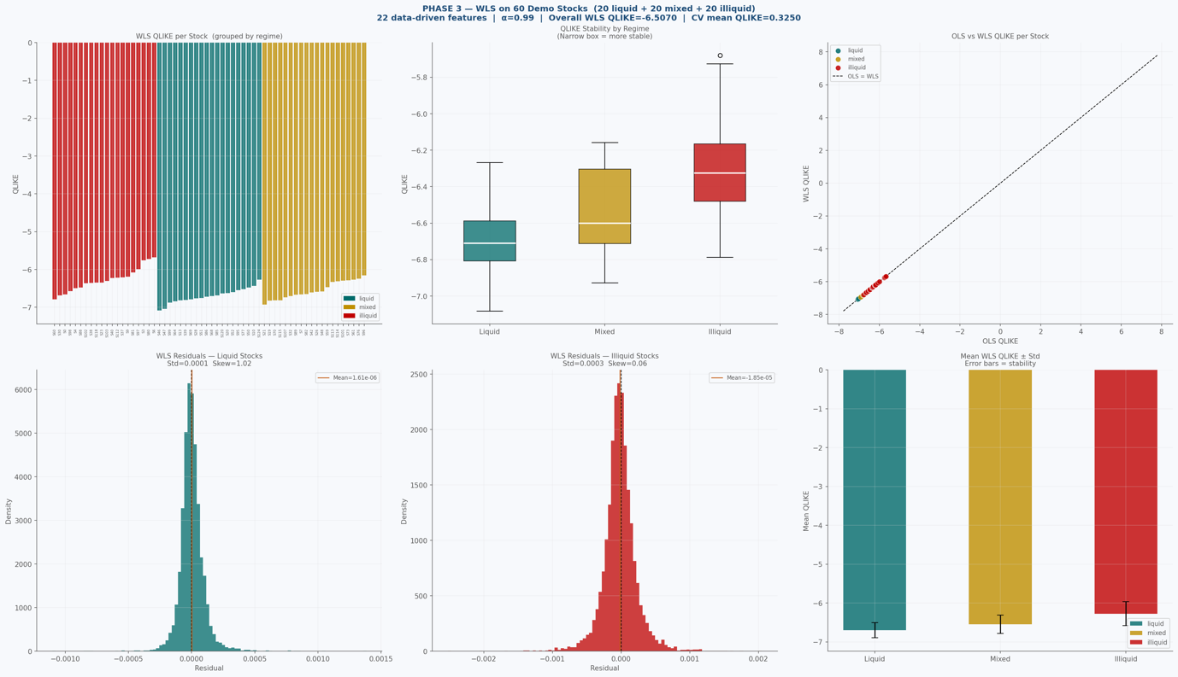

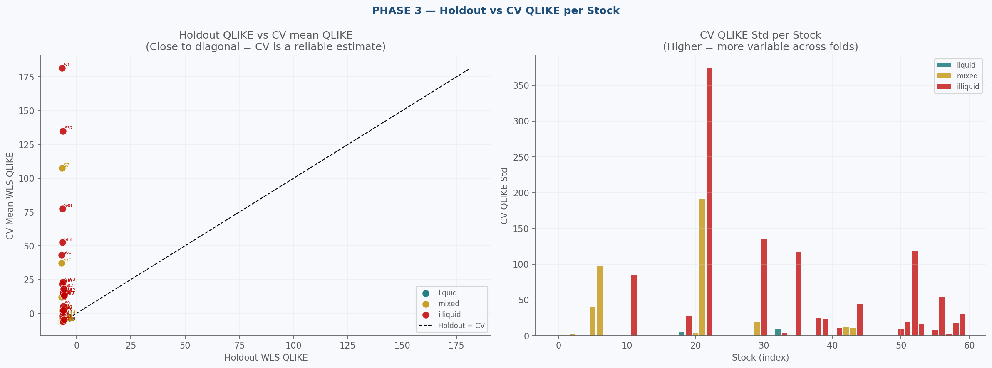

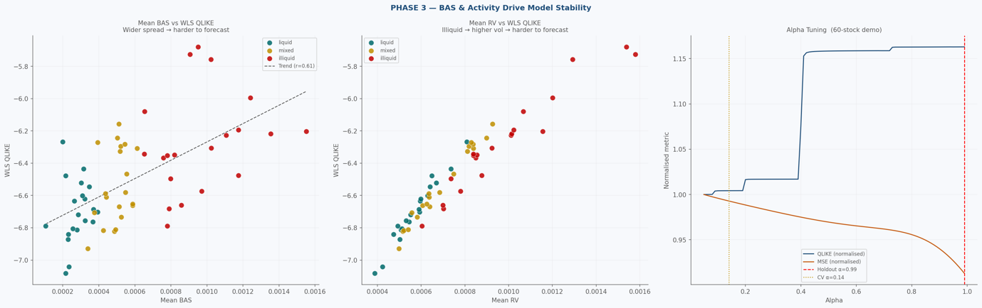

██████████████████████████████████████████████████████████████████████
FINAL SUMMARY
██████████████████████████████████████████████████████████████████████

── CONFIGURATION ──
Random seed : 42
Time ID subsample : 300 randomly sampled time_ids (of 3830 total)
Sampled time_ids : [256, 650, 745, 748, 785, 1070, 1178, 1227, 1359, 1820, 1904, 2006, 2037, 2185, 2331, 2410, 2444, 2525, 2553, 2593, 2631, 2656, 2659, 2867, 2893, 2917, 3146, 3152, 3406, 3607, 3721, 3884, 3921, 4004, 4158, 4173, 4364, 4493, 4560, 4627, 4723, 4743, 4850, 4905, 5032, 5063, 5305, 5340, 5458, 5470, 5598, 5620, 5743, 5825, 5829, 5916, 6177, 6476, 6626, 6693, 6979, 7041, 7219, 7270, 8081, 8191, 8196, 8256, 8448, 8534, 8583, 8585, 8665, 8721, 8763, 9077, 9153, 9302, 9352, 9367, 9456, 9564, 9700, 9862, 9918, 10017, 10042, 10488, 10604, 10702, 10725, 10776, 10781, 10994, 11090, 11243, 11375, 11508, 11869, 11940, 12030, 12420, 12579, 12581, 12676, 12834, 12957, 12991, 13180, 13235, 13269, 13362, 13382, 13410, 13421, 13432, 13451, 13452, 13598, 13821, 13900, 13941, 13960, 13986, 14001, 14004, 14077, 14125, 14235, 14246, 14247, 14278, 14279, 14311, 14465, 14752, 14769, 14810, 14976, 15061, 15209, 15276, 15280, 15319, 15341, 15400, 15448, 15499, 15516, 15529, 15547, 16086, 16288, 16438, 16570, 16802, 16816, 16910, 17013, 17056, 17058, 17157, 17169, 17172, 17191, 17264, 17398, 17983, 18012, 18180, 18200, 18218, 18400, 18509, 18595, 18629, 18792, 18916, 19065, 19072, 19180, 19226, 19385, 19499, 19554, 19678, 19994, 20063, 20172, 20199, 20317, 20418, 20457, 20469, 20673, 20691, 20732, 20972, 21079, 21083, 21208, 21272, 21428, 21445, 21685, 21734, 22011, 22120, 22217, 22304, 22392, 22519, 22622, 22635, 22750, 22829, 23030, 23185, 23228, 23232, 23337, 23642, 23708, 23819, 23823, 23858, 23903, 24157, 24179, 24388, 24393, 24396, 24473, 24535, 24816, 24817, 25019, 25087, 25312, 25318, 25335, 25369, 25389, 25488, 25501, 25599, 25654, 25854, 26208, 26337, 26447, 26568, 26844, 27020, 27278, 27304, 27313, 27711, 27868, 28070, 28512, 28541, 28634, 28697, 29316, 29507, 29570, 29592, 29853, 30412, 30454, 30527, 30598, 30748, 30790, 30816, 30896, 31055, 31083, 31119, 31138, 31327, 31412, 31482, 31522, 31656, 32126, 32186, 32200, 32249, 32277, 32322, 32376, 32463, 32590, 32653, 32662, 32680, 32746, 32748]
CV folds : 5-fold TimeSeriesSplit (temporal order preserved)
Stocks per regime : 20 random

── DEMO STOCKS ──
Liquid (20): [10, 13, 20, 28, 39, 46, 47, 50, 51, 52, 64, 68, 69, 77, 85, 86, 95, 99, 120, 124]
Mixed (20): [7, 19, 21, 26, 32, 42, 48, 59, 61, 70, 73, 76, 82, 89, 96, 101, 107, 113, 114, 115]
Illiquid (20): [0, 3, 4, 6, 9, 23, 30, 37, 38, 40, 60, 80, 81, 88, 97, 98, 102, 103, 112, 118]

── FEATURE SELECTION (stock_id=1 training data) ──
Candidate pool : 32 features
|r| threshold : 0.05
Collinearity cap : 0.95
Final features : 22 → ['rv_roll_mean', 'bas', 'bas_roll_mean', 'rv_lag1', 'rv_lag2', 'rv_lag3', 'bas_sq', 'log_activity', 'rel_spread_vol', 'log_activity_lag1', 'rv_roll_sd', 'bas_roll_sd', 'inv_spread', 'rv_lag1_sq', 'inv_spread_lag1', 'spread_change_vol', 'rv_roll_cv', 'wap', 'wap_dev', 'wap_return2', 'wap_return', 'bas_pct_change']

── PHASE 1 (stock_id=1) ──
Holdout: α=0.61 OLS_QLIKE=-6.288976 WLS_QLIKE=-6.290145
CV (5-fold): mean_QLIKE=-1.837962 std=9.736449 best_α=0.99

── PHASE 2 (all stocks) ──
liquid=39 illiquid=43 mixed=30

── PHASE 3 (60 stocks) ──
Holdout: α=0.99 OLS_QLIKE=-6.507159 WLS_QLIKE=-6.507046
CV (5-fold): mean_QLIKE=0.324978 std=1.139323 best_α=0.14
Liquid std=0.196467 Mixed std=0.233306 Illiquid std=0.311139

Done.

